**SUPPLEMENTAL INFORMATION**

**Single-cell-resolution transcriptome map of human, chimpanzee, bonobo, and macaque brains**

Ekaterina Khrameeva§, Ilia Kurochkin§, Dingding Han§, Patricia Guijarro, Sabina Kanton, Malgorzata Santel, Zhengzong Qian, Shen Rong, Pavel Mazin, Marat Sabirov, Matvei Bulat, Olga Efimova, Anna Tkachev, Song Guo, Chet C. Sherwood, J. Gray Camp, Svante Paabo*, Barbara Treutlein*, Philipp Khaitovich*

**TABLE OF CONTENT**

**Supplemental methods**

**Supplemental figures S1 – S57**

**Supplemental tables S1 – S10**

**Supplemental references**

**SUPPLEMENTAL METHODS**

**Sample dissection**

All brains were previously frozen in liquid nitrogen (humans, chimpanzees, macaques) or in isopentane/dry ice (bonobos) and stored at -80°C until used. All human brains, one chimpanzee brain and one macaque brain were sliced as separate hemispheres in coronal orientation before freezing and storage; the remaining brains were frozen and stored as entire hemispheres and, before sample dissection, hemispheres were atemperated to -15°C and sliced in coronal orientation. All brain slices were stored at -80°C. For sample dissection, *The Atlas of the Human Brain* [Mai et al., 2016]and *The Rhesus Monkey Brain* [Paxinos et al., 2009] were used to locate the areas of interest in human and macaque brains respectively. As there is no equivalent published resource for chimpanzee and bonobo brains, chimpanzee and bonobo areas were located using *The Atlas of the Human Brain*. Hemispheres/slices were atemperated to -20°C prior to dissection, placed on a metal board previously cleaned with 75% ethanol and chilled at -80 C, and pieces of 10-60 mg were cut out of selected areas using a metal scalpel. Dissected samples were then collected with tweezers, put into tubes and immediately stored at -80°C. Dissection was performed on dry ice. All materials used during dissection (scalpels, tweezers, tubes) were sterile and chilled in dry ice at -80°C before use.

**RNA equencing (RNA-seq)**

Sequencing libraries were prepared with NEBNext® Ultra™ II RNA Library Prep Kit (New England Biolabs) according to manufacturer’s instructions. Briefly, poly(T) oligo-attached magnetic beads were used to isolate long polyadenylated RNA from 100 ng of total RNA. After fragmentation, first-strand cDNA was reverse transcribed with random hexamer-primers, followed by second-strand cDNA synthesis, end repair, adenylation of 3′ ends, and ligation of the adapters. Fragments were then enriched by PCR and sequenced on the Illumina HiSeq 4000 system using the 150-bp paired-end sequencing protocol. All samples were randomized with respect to species prior to library preparation and RNA sequencing.

**Single-nuclei sequencing (snRNA-seq)**

All steps were performed on ice, and spinning of the samples was performed at 4°C. The pooled tissue pieces for each set were minced on ice using a scalpel and then washed into a Dounce homogenizer using PBSE (PBS + 2 mM EDTA) + 1% BSA + 0.3 M Sucrose and dounced with 10 strokes using pestle A followed by 10 strokes using pestle B. The homogenate was transferred to a 15 ml tube and spun down 5 min at 900×g. The supernatant was aspirated, the pellet resuspended 20 times in PBSE + 1% NP-40 and incubated for 7 min on ice to deliberate nuclei. The homogenate was spun down 5 min at 900×g, and the supernatant was aspirated. The pellet was washed 2 times using PBSE + 1% BSA and once using PBS + 1% BSA. Nuclei were stained using DAPI (BD Pharmingen, 1:1000 dilution) and filtered through a 30 um strainer (Miltenyi Biotec) before sorting. Sorting was performed using a FACS Fusion (BD) to sort for DAPI+ positive events and to remove debris and doublets. After sorting, nuclei were spun for 5 min at 900×g and resuspended in PBS + 1% BSA to be loaded on the 10x microfluidic chip device. All, except one (ACC1), of the obtained single nuclei suspensions were loaded on two lanes of a 10x microfluidic chip device.

Single nuclei experiments were performed using a 10x Chromium single cell 3’ v2 reagent kit by precisely following the detailed protocol of the manufacturer to construct 10x Genomics single-cell 3’ libraries. Each library was barcoded using the i7 barcodes provided by 10x. Single nucleus libraries were pooled at equal ratios and run using paired-end sequencing on the NovaSeq 6000 platform (Illumina) according to manufacturer’s instructions.

**RNA-seq data processing**

To remove Illumina universal adapters and low-quality bases at the ends of reads, we used Trimmomatic [Bolger et al., 2014] with the following parameters: "PE -phred33 ILLUMINACLIP:all.fa:2:30:10:2:true SLIDINGWINDOW:4:15 LEADING:3 TRAILING:3 MINLEN:20". The union of all adapter sequences provided by Trimmomatic was used, as well as an additional sequence of Illumina universal adapter found by FastQC (AGATCGGAAGAG), for palindrome clipping. Reads were further mapped to the corresponding reference genomes (GRCh38, Mmul_8.0.1, panpan1.1 and Pan_tro_3.0) using HISAT2 [Kim et al., 2015] with the following parameters: "--no-softclip --max-intronlen 1000000  -k 20". Gene expression levels were estimated as Transcripts Per Million (TPM) using StringTie [Pertea et al., 2015] with the following parameters: "-e -G reference.gtf -B out -A out.tab". Reference genome sequences, gene annotations and orthologous gene tables for all species were obtained from Ensembl v91 [Zerbino et al., 2018]. One-to-one orthologous protein-coding genes with TPM>1 were used in further analysis. TPMs were further normalized by the sample median, and log-transformed.

**Comparison with external data sets**

To test the robustness of clustering procedure, we compared our clusters with previously published data from Allen Human Brain Atlas (AHBA) [Hawrylycz et al., 2012]. First, we selected regions from AHBA that correspond to regions from our dataset. Next, we assigned a cluster label to each region from AHBA based on the association between the regions from AHBA and our dataset. Further, we calculated average gene expression values within each cluster of AHBA and our dataset. Finally, we calculated the pairwise Pearson correlation coefficient for each corresponding cluster between AHBA and our dataset (Supplemental Fig. S4; Supplemental Table S9).

We compared gene expression levels that were obtained in our study with a previously published dataset containing 16 brain regions in human and non-human primates [Sousa et al., 2017a]. We employed the same read mapping and counting procedures as described above for RNA-seq reads from the National Center for Biotechnology Information BioProjects database, accession number PRJNA236446 [Sousa et al., 2017]. The resulting TPM values were log2 transformed, and then quantile normalization was applied. The correspondence between the brain regions in [Sousa et al., 2017] and in our dataset was based on anatomical localization of regions in the human brain. Separately for each dataset and region, we classified genes that demonstrated expression differences between human and chimpanzee using *t*-test (p-value < 0.05). For genes that passed *t*-test threshold in both datasets, we calculated log2-fold changes between gene expression levels in human and chimpanzee (Supplemental Fig. S19A). To check if log2-fold change values were in agreement between datasets, we performed Fisher’s exact test (Supplemental Fig. S19B). The same analysis was done for comparison of gene expression levels between human and macaque (Supplemental Fig. S19C,D), and between human and average gene expression in chimpanzee and macaque (Supplemental Fig. S19E,F).

**Single-nuclei data processing**

At the first step, *cellranger mkfastq* was used to convert binary base call (BCL) files to FASTQ files and to decode the multiplexed samples simultaneously [Zheng et al., 2017]. Next, *cellranger count* was applied to the obtained FASTQ files [Zheng et al., 2017]. It performed sequencing alignment using STAR v2.5.3a [Dobin et al., 2013] to a concatenation of human (hg38), chimpanzee (panTro5), bonobo (panPan2) and macaque (rheMac8) reference genome assemblies.

To assign each nucleus to a species, we first used a custom Perl script to calculate the number of UMIs mapped to each species reference genome per nucleus, based on BAM files generated by cellranger. Another custom R script was used to assign a nucleus to species [R Core Team, 2017]. First, the table was normalized for the total number of UMIs per species, to balance the mappability differences arising due to the evolutionary differences between the primate species. Then, a nucleus was assigned to a particular species if >50% of its UMIs were mapped to this species. The threshold of 50% was chosen based on the distribution of maximal proportions of UMI mapped to one species per nucleus (Supplemental Fig. S53). A total of 107,019 nuclei assigned to species with at least 500 unique detected molecules were used in further analysis (Supplemental Table S10).

To calculate gene expression values, we remapped each nucleus to the reference genome assembly of an assigned species using *cellranger count* [Zheng et al., 2017]. It performed sequencing alignment using STAR v2.5.3a [Dobin et al., 2013] to human (hg38), chimpanzee (panTro5), bonobo (panPan2) and macaque (rheMac8) reference genome assemblies separately. To generate the gene expression matrix, a list of UMIs in each gene and within each nucleus was assembled, then UMIs within ED = 1 were merged together. The total number of unique UMI sequences was counted, and this number was reported as the number of transcripts of that gene for a given nucleus. A total of 88,047 nuclei were reported by *cellranger count* at this step [Zheng et al., 2017].

Additionally, to confirm that gene expression values were calculated correctly, we applied an alternative procedure of gene expression calculation and nucleus-to-species assignment based on the human-chimpanzee-bonobo-macaque consensus genome [Kanton et al., 2019], and obtained highly similar results (Supplemental Fig. S54).

**Immunohistochemistry**

For multiple immunofluorescent histochemistry, 20 µm thick cryosections were prepared from samples of the anterior cingulate cortex (BA24) from three humans, three chimpanzees, and three rhesus monkeys (Supplemental Table S1). All samples were previously frozen in liquid nitrogen and stored at -80°C until used.

Sections were thaw-mounted onto microscope slides and fixed with 4% paraformaldehyde solution for 7 min followed by washing in phosphate-buffered saline – 0.1M PBS (pH 7.4) three times for 5 min. Then sections were preincubated in PBST (0.5% Triton X-100 in PBS) with 5% normal donkey serum (NDS) and 5% normal horse serum (NHS) for 1 h. Reaction with a mixture of primary antibodies (Supplemental Table S7) consisting of one antibody against the human-specific antigen and one cell-type marker was performed in the blocking buffer (2.5% NDS and 2.5% NHS in PBST) for 24 h at 4°C in Shandon coverplates. We used rabbit anti-NFAT5 (NB120-3446) and mouse anti-MSI2 (NBP2-45837) antibodies against human-specific antigens, as well as glial goat anti-GFAP (PA5-18598), neuronal mouse anti-NeuN (MAB-377), and rabbit anti-NeuN (24307) antibodies against cell-type markers.

Following washing and incubation with biotinylated horse anti-rabbit (BA-1100) or mouse (BA-2000) IgG corresponding to primary human-specific antigen antibody, in the blocking buffer for 2 h at room temperature, sections were rinsed in PBST. Sections were processed with a mixture of donkey anti-goat Alexa Fluor 488 (A-11055) or anti-mouse Alexa Fluor 488 (A-21202) / anti-rabbit Alexa Fluor 488 (A-21206) and streptavidin-Alexa Fluor 568 conjugate (S-11226) for 2 h (Supplemental Table S7). After a wash in PBST, sections were incubated in 1% Sudan black B solution in 70% ethanol for 10 min to block lipofuscin autofluorescence. Then washed in PBS and mounted with Fluoromount aqueous mounting medium (Sigma-Aldrich) with blue fluorescent nuclear counterstain DAPI, coverslipped and sealed with nail polish. No staining was seen in control sections processed without the primary antibody staining.

**Immunohistochemistry image processing**

AC sections immunostained with antibodies against NFAT5 and MSI2 proteins were subjected to quantitative analysis. Astrocytic processes density was calculated in three sections per sample in three humans, three chimpanzees, and three macaques (Fig. 7C, Supplemental Fig. S44). To track expression inhomogeneity among cortical layers, tiles consisting of 2×6 fields of view (Fig. 7F) were stitched to cover upper part (~1 mm) of the cortex using ZEN (Zeiss). Intellesis ZEN Module was used to segment NFAT5- or MSI2-positive astrocytic processes from neuronal nuclei and background. Mean density of segmented objects was measured for each image (Fig. 7D, Supplemental Fig. S44). To test the significance of differences between species and between cortical layers in each of the species, two-sided *t*-test with Holm-Sidak correction was performed.

**Western blot analysis**

Macaque and chimpanzee anterior cingulate cortex samples were lysed in RIPA lysis buffer (150 mM NaCl, 1% Triton X-100, 0,5% sodium deoxycholate, 0,1% SDS, 20 mM Tris-HCl, pH 7.5) and processed using a standard western blotting protocol. Briefly, the lysate mixture was centrifuged at 400C for 20 minutes at 12,000 rpm. The supernatant was transferred to a fresh tube on ice. The protein concentration of each lysate was determined with NanoDrop. 25 μg/lane protein was added to an equal volume of 2× Laemmli buffer. The samples were denatured by boiling the lysates in sample buffer at 95-1000C for 5 minutes and then cooled in the ice. 10% polyacrylamide gel was prepared. The electrophoresis apparatus was filled with 1× running buffer. Samples containing equal amounts of protein prepared in sample buffer and a molecular weight marker were loaded in one of the lanes of the SDS-page. The gel was run for 20 minutes at 90 V and 20-25 mA for one gel and for 40 minutes at 180 V and 20-25 mA for one gel. After electrophoresis, the gel from the electrophoresis apparatus was removed and equilibrated by soaking in the transfer buffer for 10 minutes. The nitrocellulose membrane was prepared by soaking in the transfer buffer for 10 min, as well as filter papers and sponges, and the sandwich was prepared. The sandwich was placed into the transfer cassette, and the wet transfer was performed at 7 V and 100 mA for 30 min. After transfer, the membrane was rinsed in 1× TBST. Then, the membrane was incubated in 1× TBST with 5% milk for 1 hour at room temperature with constant rocking. The membrane was rinsed three times for five minutes in 1× TBST.

Anti-NFAT rabbit polyclonal antibody (1:1000, NB120-3446, Novus Biologicals) and Musashi-2 mouse monoclonal antibody (OTI2F10) (1:1000, NBP2-45837, Novus Biologicals) were used as primary antibodies. BM Chemiluminescence Western Blotting Mouse/Rabbit Kit (11520709001; Roche Diagnostics, Indianapolis, IN) was used for the detection of membrane-bound molecules according to the manufacturer’s instructions. Blots were exposed to and analyzed by the FUSION FX chemiluminescence imaging system (Supplemental Fig. S51). Thus, Western Blot analysis confirmed that antibodies against NFAT5 and MSI2 detected the same proteins in macaque and chimpanzee brains as in the human brain with high specificity.

**SUPPLEMENTAL FIGURES**

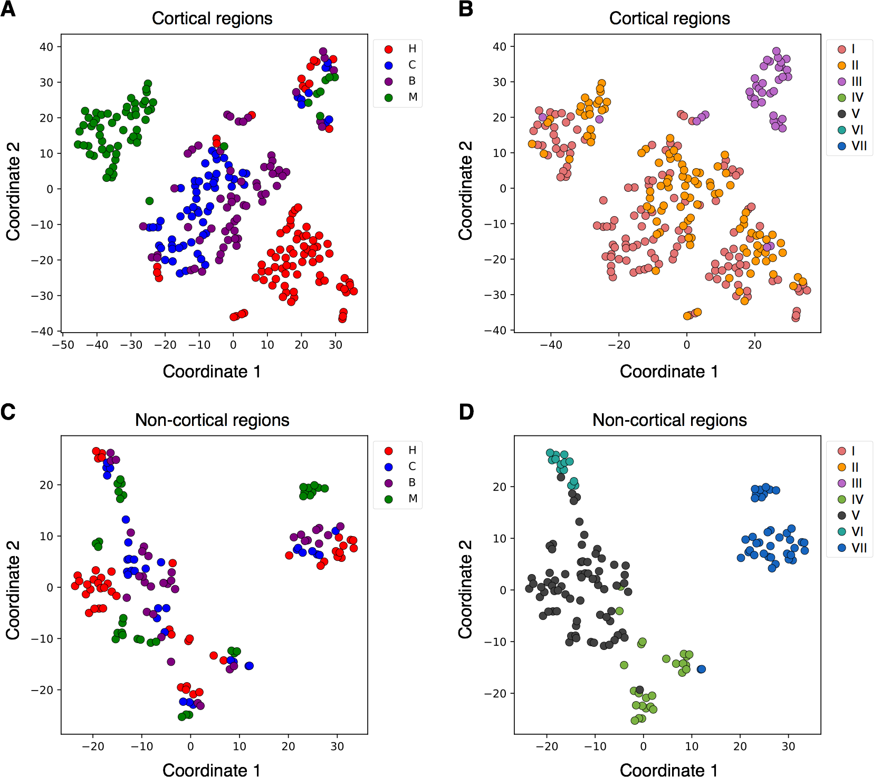

Supplemental Fig. S1. *t*-SNE plots visualizing samples corresponding to 33 brain regions of four species. Each circle represents one sample. (A) Samples corresponding to the cortical regions. Colors represent species: human (red), chimpanzee (blue), bonobo (violet), and macaque (green). (B) Samples corresponding to the cortical regions. Colors represent seven clusters, as in Fig. 1. (C) Samples corresponding to the non-cortical regions. Colors represent species: human (red), chimpanzee (blue), bonobo (violet), and macaque (green). (D) Samples corresponding to the non-cortical regions. Colors represent seven clusters, as in Fig. 1.

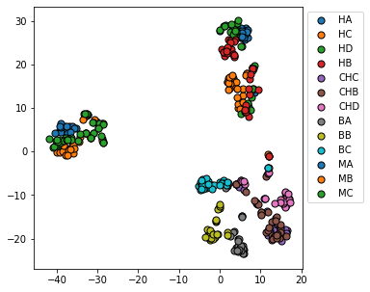

**Supplemental Fig. S2.** *t*-SNE plots based on expression variation among all 422 analyzed samples. Each circle represents a sample. Circle colors represent individuals.

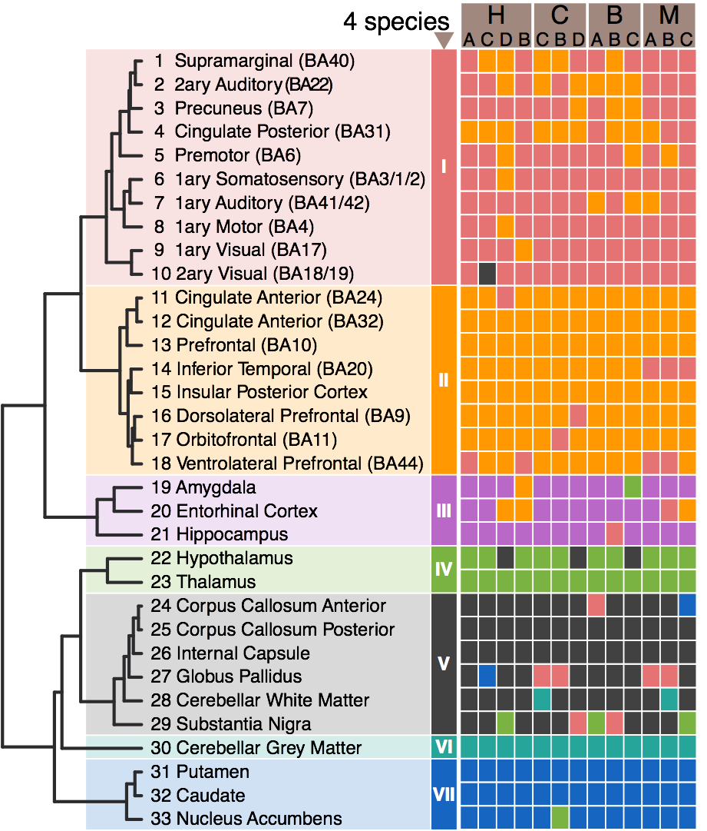

Supplemental Fig. S3. Unsupervised hierarchical clustering of brain regions based on average gene expression values among four species. Regions within each individual brain are assigned to the nearest cluster.

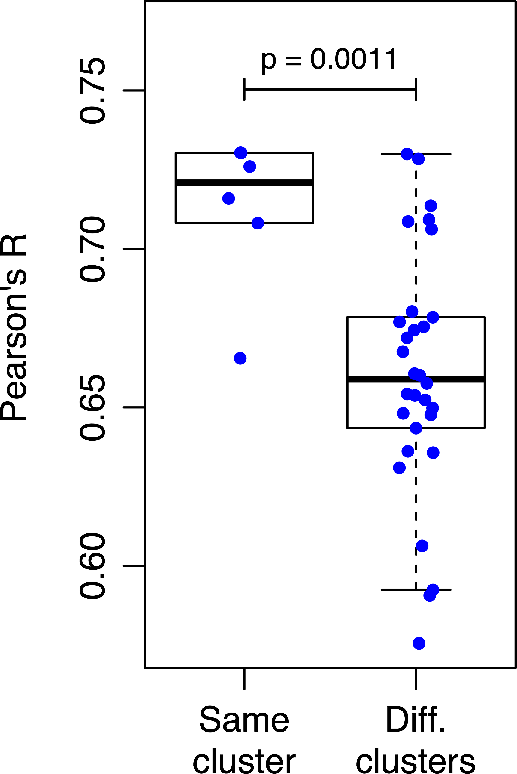

**Supplemental Fig. S4.** Correlation of average gene expression values between Allen Brain Atlas [Hawrylycz et al., 2012] and our study. Each dot shows Pearson’s R between two clusters of brain regions. Average gene expression values were calculated among brain regions in each cluster.

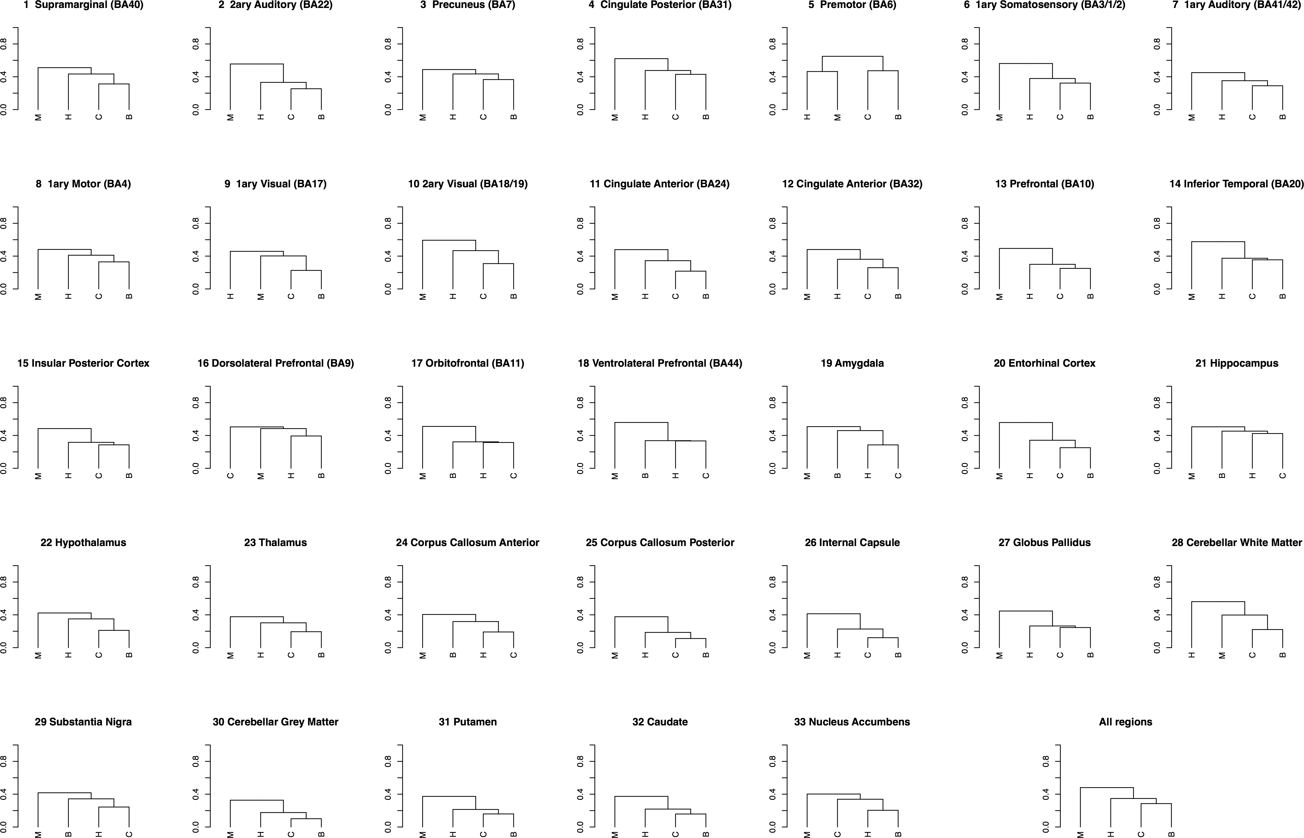

**Supplemental Fig. S5.** Phylogenetic trees reconstructed with UPGMA method based on the expression differences identified using ANOVA with both species and regions variables as factors.

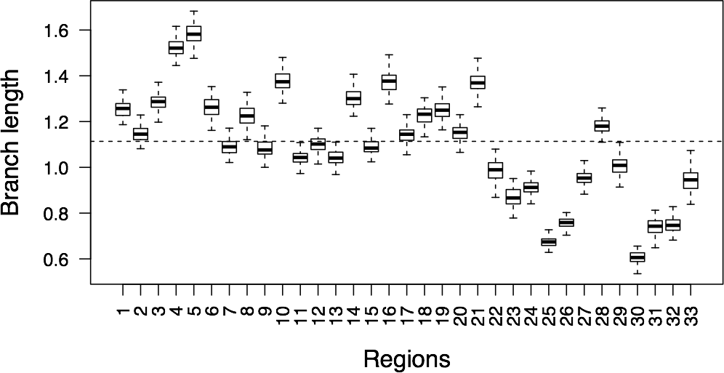

**Supplemental Fig. S6.** Total branch length calculated for the reconstructed phylogenetic trees in 33 brain regions. The dashed line represents the average branch length among all 33 brain regions.

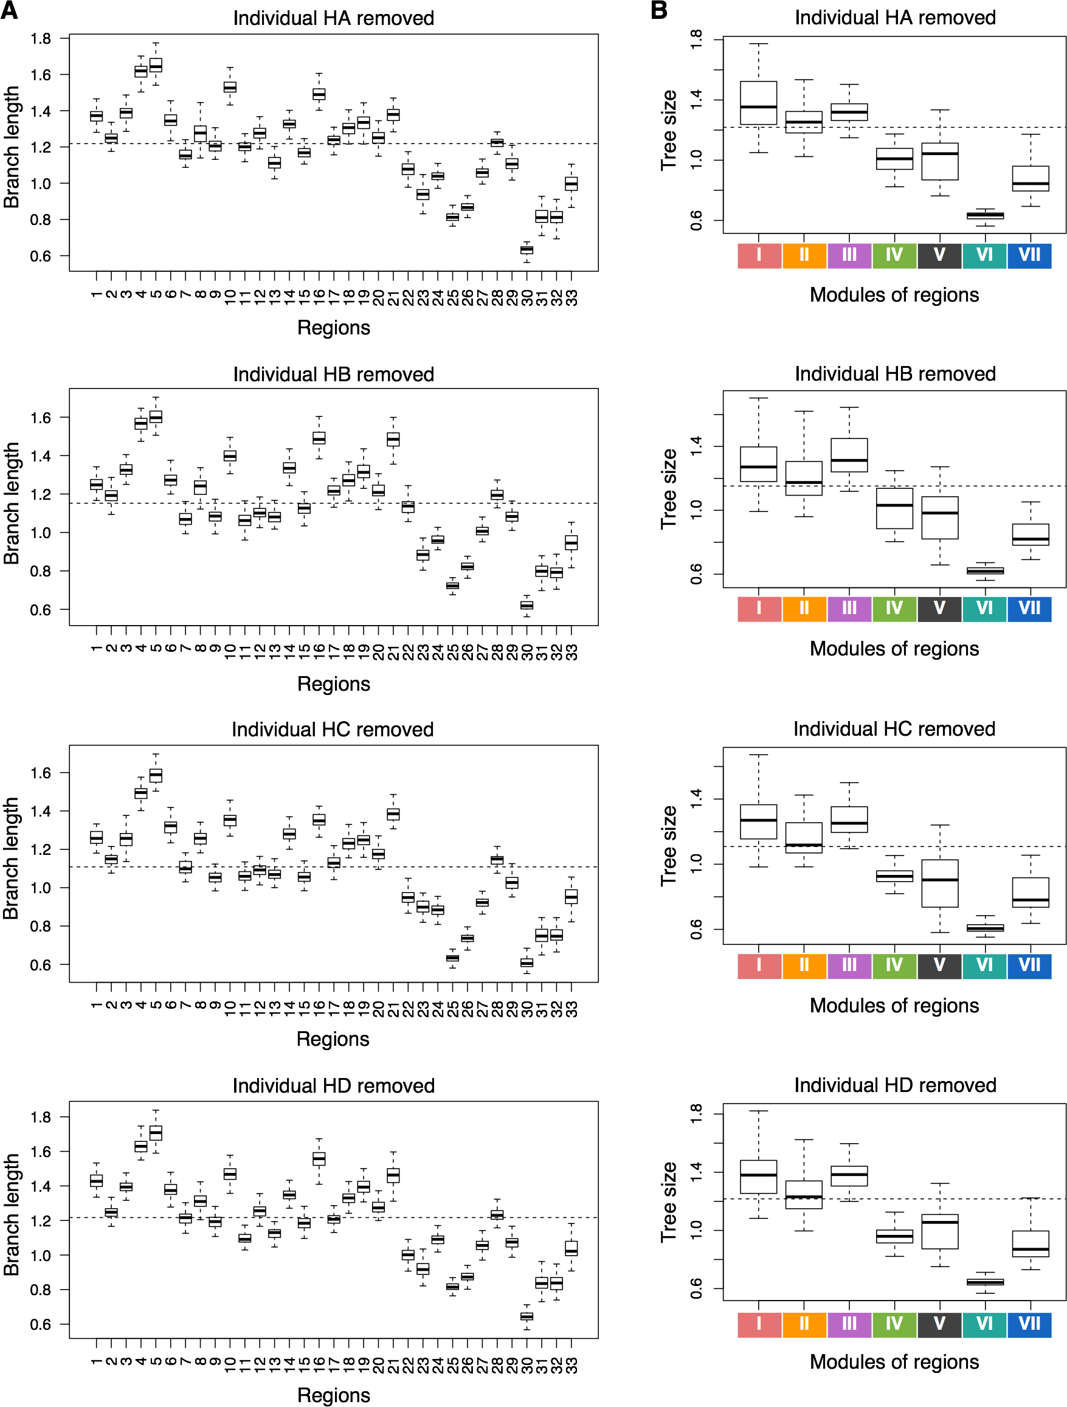

**Supplemental Fig. S7.** Branch lengths based on the leave-one-out analysis removing one human individual (HA, HB, HC, or HD) at a time. (**A**) Total branch length calculated for the reconstructed phylogenetic trees in 33 brain regions. (**B**) Total branch length calculated for the reconstructed phylogenetic trees for each of 33 brain regions grouped by expression-based regional clusters I-VII, as in Fig. 1G. The dashed line represents the average branch length among all 33 brain regions.

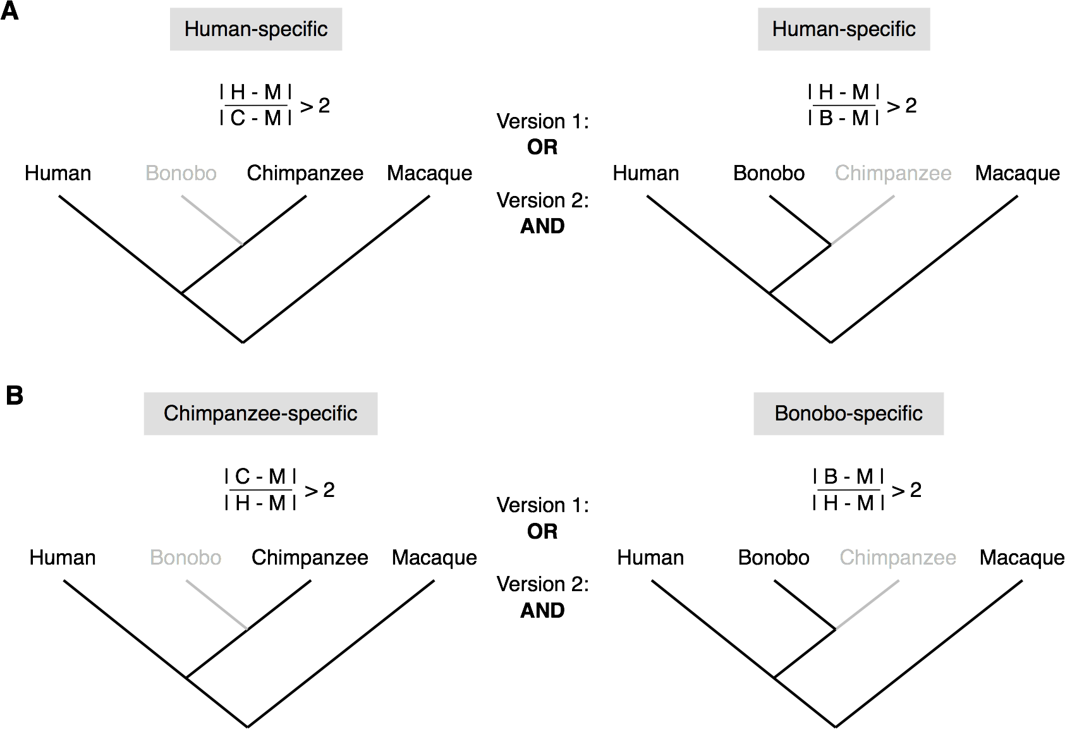

**Supplemental Fig. S8.** The schematic representation of the phylogenetic tree highlighting the branches used for the estimates of species-specific expression differences. (**A**) Human-specific expression differences are defined as the ones showing 2-fold greater human/macaque difference relative to chimpanzee/macaque (left) or bonobo/macaque (right) differences. (**B**) Chimpanzee-specific expression differences are defined as the ones showing 2-fold greater chimpanzee/macaque difference relative to human/macaque difference. Bonobo-specific expression differences are defined similarly.

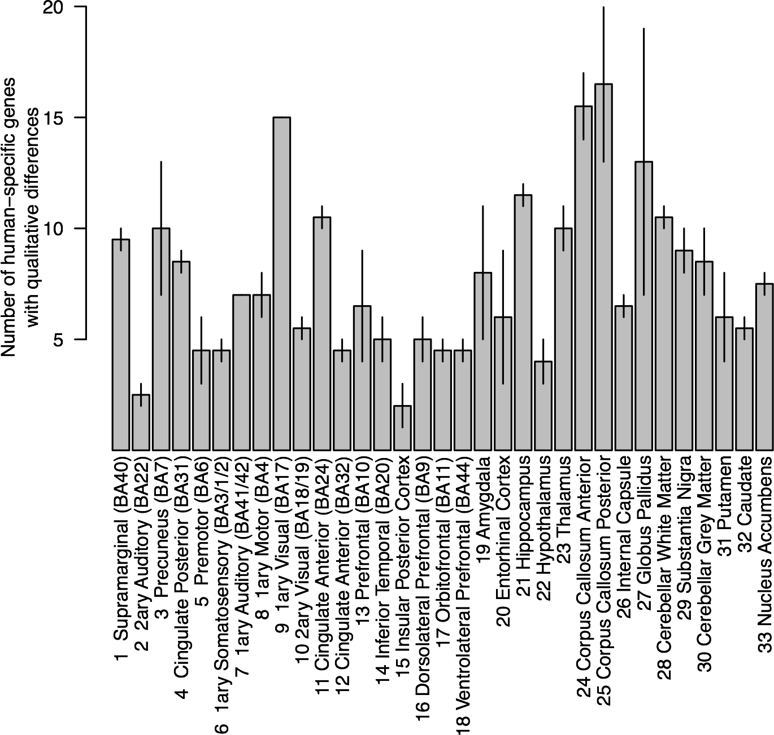

**Supplemental Fig. S9.** Numbers of genes demonstrating a complete expression loss either in humans or in non-human primates in each brain region. The differences were defined as those showing two-fold greater human-macaque expression difference relative to the chimpanzee-macaque or bonobo-macaque difference (i.e., |H-M| / |C-M| > 2 OR |H-M| / |B-M| > 2). The bars show the mean of the chimpanzee-based and bonobo-based comparisons. The error bars span the difference between chimpanzee-based and bonobo-based estimates.



**Supplemental Fig. S10.** Correlation between numbers of expressed genes and numbers of human-specific genes per region. (**A**) Numbers of human-specific genes were calculated using |H-M| / |C-M| > 2 OR |H-M| / |B-M| > 2 criteria. (**B**) Numbers of human-specific genes were calculated using |H-M| / |C-M| > 2 AND |H-M| / |B-M| > 2 criteria, additionally requiring ( |H-M| > Q or |C-M| > Q ) AND ( |H-M| > Q or |B-M| > Q ), where Q was calculated as the 0.1 percentile among all |H-M|, |C-M|, and |B-M| differences.

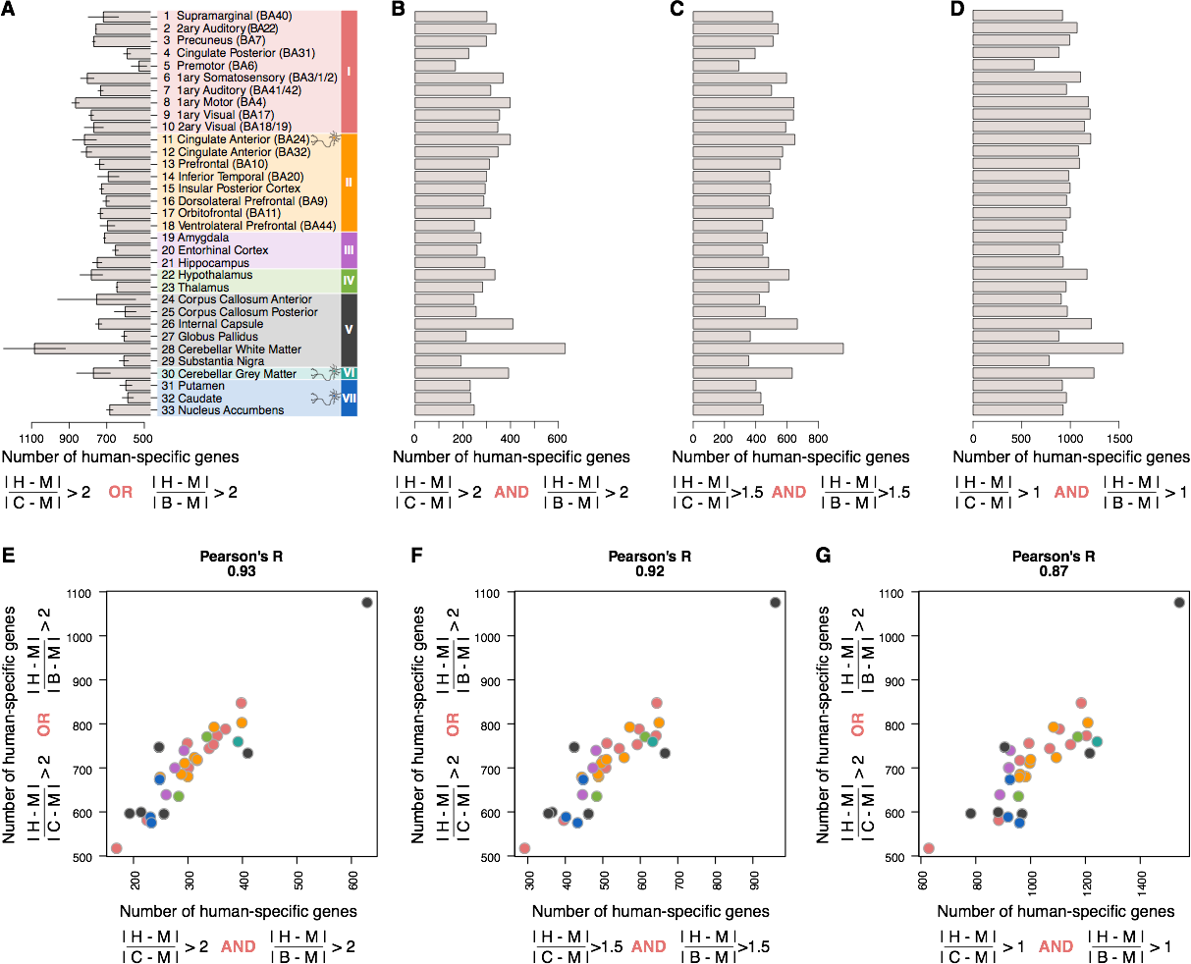

**Supplemental Fig. S11.** Comparison of two criteria for the definition of human-specific expression differences. (**A**) Numbers of human-specific genes calculated using |H-M| / |C-M| > 2 OR |H-M| / |B-M| > 2 criteria. (**B**) Numbers of human-specific genes calculated using |H-M| / |C-M| > 2 AND |H-M| / |B-M| > 2 criteria, additionally requiring ( |H-M| > Q or |C-M| > Q ) AND ( |H-M| > Q or |B-M| > Q ), where Q was calculated as the 0.1 percentile among all |H-M|, |C-M|, and |B-M| differences. (**C**) Numbers of human-specific genes calculated using |H-M| / |C-M| > 1.5 AND |H-M| / |B-M| > 1.5 criteria, additionally requiring ( |H-M| > Q or |C-M| > Q ) AND ( |H-M| > Q or |B-M| > Q ), where Q was calculated as the 0.1 percentile among all |H-M|, |C-M|, and |B-M| differences. (**D**) Numbers of human-specific genes calculated using |H-M| / |C-M| > 1 AND |H-M| / |B-M| > 1 criteria, additionally requiring ( |H-M| > Q or |C-M| > Q ) AND ( |H-M| > Q or |B-M| > Q ), where Q was calculated as the 0.1 percentile among all |H-M|, |C-M|, and |B-M| differences. (**E-G**) Correlation between numbers of human-specific genes calculated in (A) and in (B-D). Colors represent clusters of brain regions, as in Fig. 1.

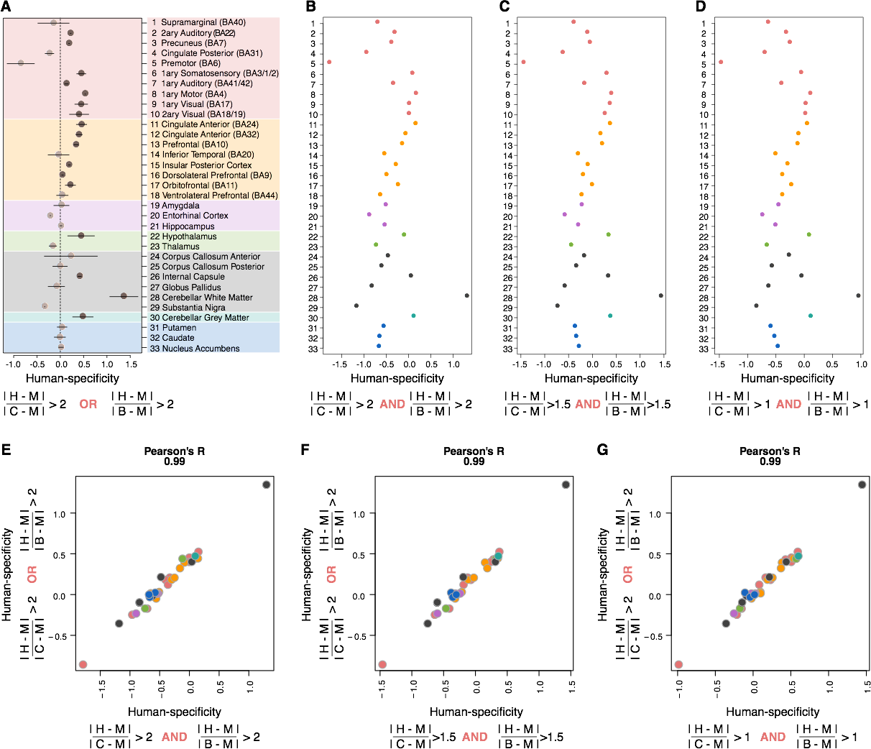

**Supplemental Fig. S12.** Comparison of two criteria for the definition of human-specificity ratios. (**A**) Human-specificity ratios calculated using |H-M| / |C-M| > 2 OR |H-M| / |B-M| > 2 criteria. (**B**) Human-specificity ratios calculated using |H-M| / |C-M| > 2 AND |H-M| / |B-M| > 2 criteria, additionally requiring ( |H-M| > Q or |C-M| > Q ) AND ( |H-M| > Q or |B-M| > Q ), where Q was calculated as the 0.1 percentile among all |H-M|, |C-M|, and |B-M| differences. (**C**) Human-specificity ratios calculated using |H-M| / |C-M| > 1.5 AND |H-M| / |B-M| > 1.5 criteria, additionally requiring ( |H-M| > Q or |C-M| > Q ) AND ( |H-M| > Q or |B-M| > Q ), where Q was calculated as the 0.1 percentile among all |H-M|, |C-M|, and |B-M| differences. (**D**) Human-specificity ratios calculated using |H-M| / |C-M| > 1 AND |H-M| / |B-M| > 1 criteria, additionally requiring ( |H-M| > Q or |C-M| > Q ) AND ( |H-M| > Q or |B-M| > Q ), where Q was calculated as the 0.1 percentile among all |H-M|, |C-M|, and |B-M| differences. (**E-G**) Correlation between human-specificity ratios calculated in (A) and in (B-D). Colors represent clusters of brain regions, as in Fig. 1.

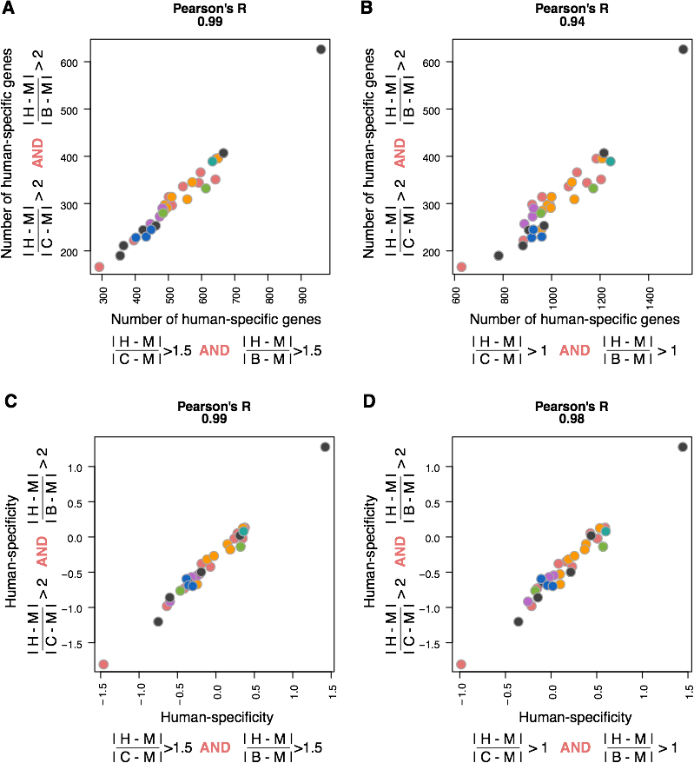

**Supplemental Fig. S13.** Comparison of cutoffs used to define human-specific genes. (**A**) Correlation between numbers of human-specific genes calculated using cutoffs 2 and 1.5. (**B**) Correlation between numbers of human-specific genes calculated using cutoffs 2 and 1. (**C**) Correlation between human-specificity ratios calculated using cutoffs 2 and 1.5. (**D**) Correlation between human-specificity ratios calculated using cutoffs 2 and 1. Colors represent clusters of brain regions, as in Fig. 1.

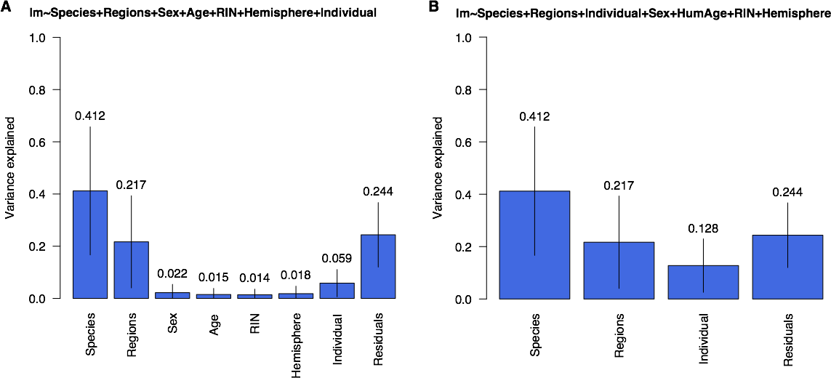

**Supplemental Fig. S14.** Variance explained by covariates. (**A**) lm ~ Species + Regions + Sex + Age + RIN + Hemisphere + Individual. (**B**) lm ~ Species + Regions + Individual + Sex + Age + RIN + Hemisphere. Bars and numbers above the bars reflect average proportions of variance explained by each covariate among all expressed genes. Lines show standard deviations of variance explained by each covariate among all expressed genes.

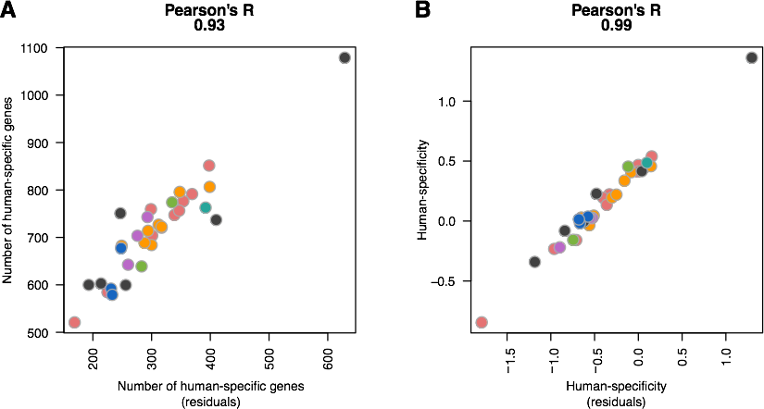

**Supplemental Fig. S15.** Comparison of the covariate adjustment procedures. X-axis: gene expression values were adjusted using a linear model as described in [Berto et al., 2019] using individual from which the sample was collected as a covariate; |H-M| / |C-M| > 2 OR |H-M| / |B-M| > 2 criteria were used. Y-axis: gene expression values were normalized by the median expression level among regions in each individual brain; |H-M| / |C-M| > 2 AND |H-M| / |B-M| > 2 criteria were used, additionally requiring ( |H-M| > Q or |C-M| > Q ) AND ( |H-M| > Q or |B-M| > Q ), where Q was calculated as the 0.1 percentile among all |H-M|, |C-M|, and |B-M| differences. (**A**) Numbers of human-specific genes. (**B**) Human-specificity ratios.

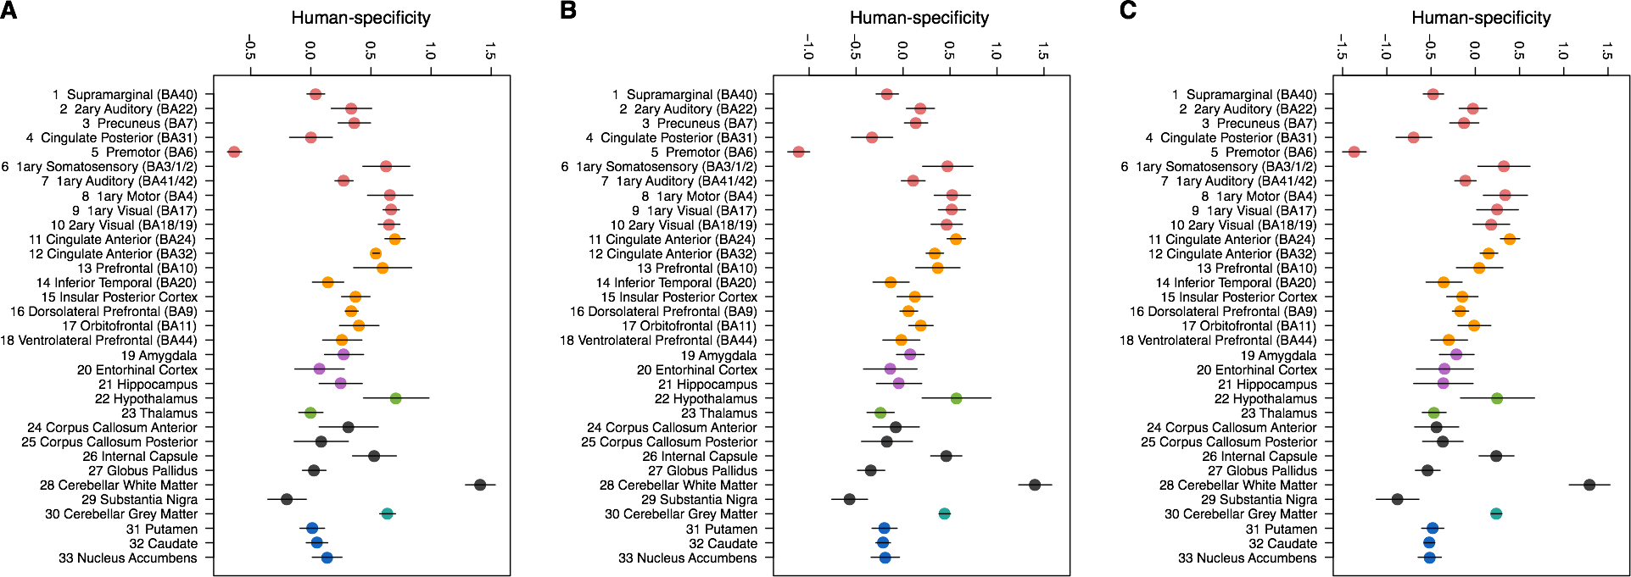

**Supplemental Fig. S16.** Human-specificity ratios based on the leave-one-out analysis removing one human individual (HA, HB, HC, or HD) at a time. Circles show the mean of the four leave-one-out estimates, while lines show the standard deviation of the four leave-one-out estimates. (**A**) Human-specificity ratios calculated using |H-M| / |C-M| > 2 AND |H-M| / |B-M| > 2 criteria, additionally requiring ( |H-M| > Q or |C-M| > Q ) AND ( |H-M| > Q or |B-M| > Q ), where Q was calculated as the 0.1 percentile among all |H-M|, |C-M|, and |B-M| differences. (**B**) Human-specificity ratios calculated using |H-M| / |C-M| > 1.5 AND |H-M| / |B-M| > 1.5 criteria, additionally requiring ( |H-M| > Q or |C-M| > Q ) AND ( |H-M| > Q or |B-M| > Q ), where Q was calculated as the 0.1 percentile among all |H-M|, |C-M|, and |B-M| differences. (**C**) Human-specificity ratios calculated using |H-M| / |C-M| > 1 AND |H-M| / |B-M| > 1 criteria, additionally requiring ( |H-M| > Q or |C-M| > Q ) AND ( |H-M| > Q or |B-M| > Q ), where Q was calculated as the 0.1 percentile among all |H-M|, |C-M|, and |B-M| differences.

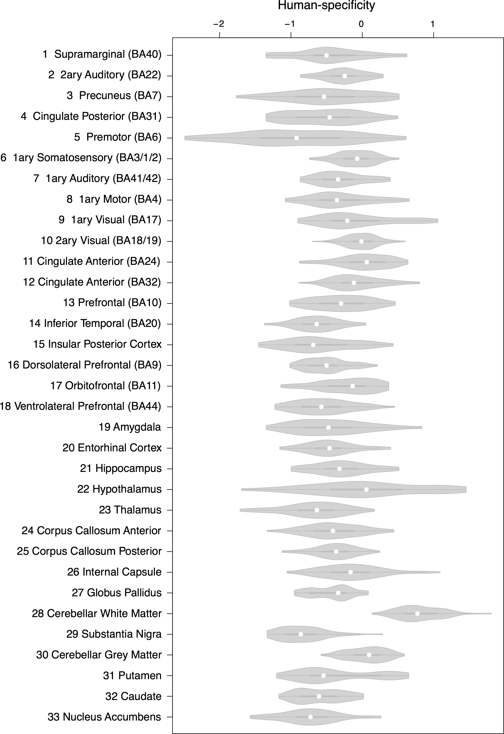

**Supplemental Fig. S17.** Human-specificity ratios based on 100 down-sampling analyses to one random individual per species per brain region. Circles show medians of the estimates. Human-specificity ratio was calculated using |H-M| / |C-M| > 2 AND |H-M| / |B-M| > 2 criteria, additionally requiring ( |H-M| > Q or |C-M| > Q ) AND ( |H-M| > Q or |B-M| > Q ), where Q was calculated as the 0.1 percentile among all |H-M|, |C-M|, and |B-M| differences.

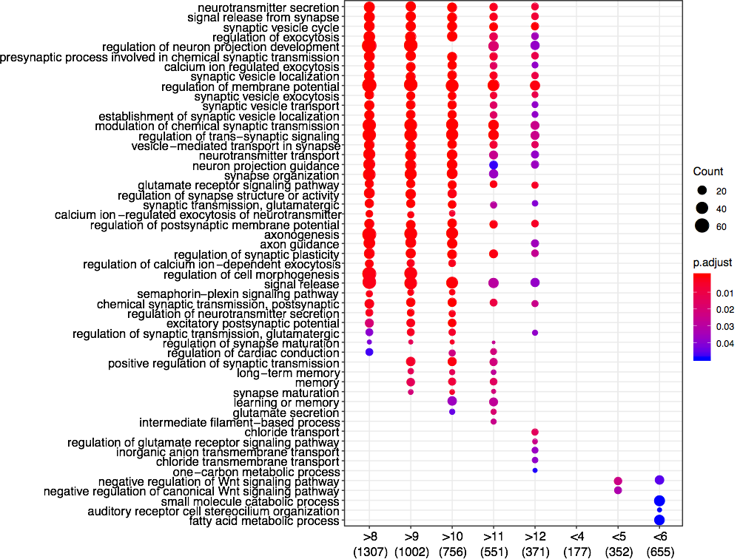

**Supplemental Fig. S18.** Top Gene Ontology (GO) functional terms enriched in the human-specific expression differences present in >8, >9, >10, >11, >12 and <4, <5, <6 out of the 33 brain regions. Numbers under the plot show numbers of genes in each analyzed list. The size of circles reflects the number of genes within the GO term. The color of circles indicates the BH-corrected enrichment p-value.

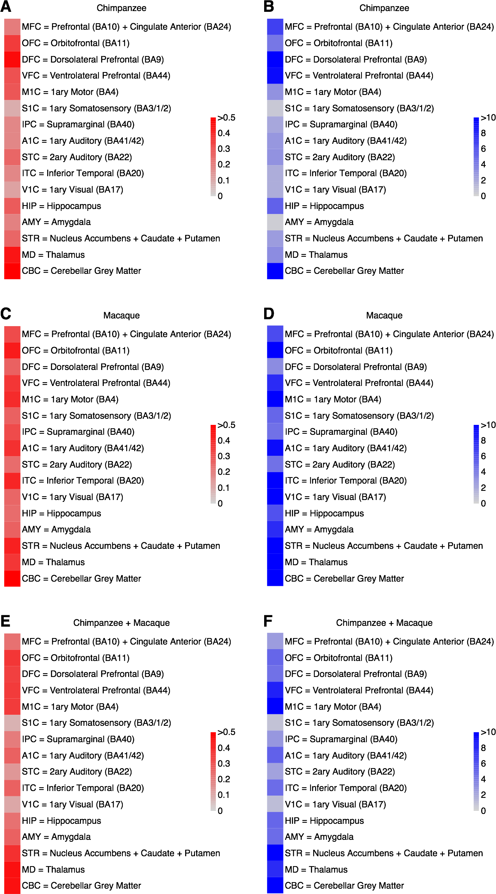

**Supplemental Fig. S19.** Comparison of gene expression levels obtained in our study with published dataset containing 16 brain regions in humans and non-human primates [Sousa et al., 2017a]. (**A**) Pearson correlation coefficients of log2 fold changes between gene expression levels in human and chimpanzee. (**B**) Fisher’s exact test p-values (log10) of log2-fold changes between gene expression levels in human and chimpanzee. (**C**) Pearson correlation coefficients of log2-fold changes between gene expression levels in human and macaque. (**D**) Fisher’s exact test p-values (log10) of log2-fold changes between gene expression levels in human and macaque. (**E**) Pearson correlation coefficients of log2-fold changes between gene expression in human and average gene expression in chimpanzee and macaque. (**F**) Fisher’s exact test p-values (log10) of log2-fold changes between gene expression in human and average gene expression in chimpanzee and macaque.

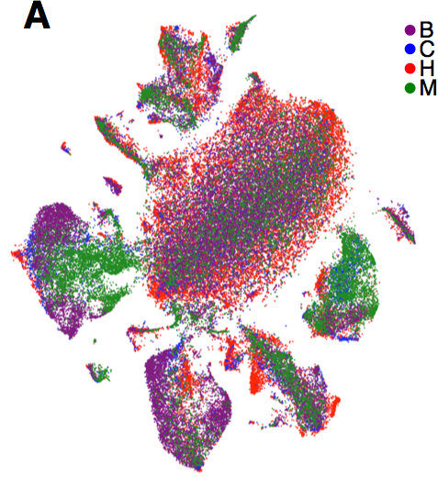

**Supplemental Fig. S20.** *t*-SNE plot of 88,047 single nuclei colored by species after integration procedure performed using *Seurat 3.0* package [Stuart et al., 2019].

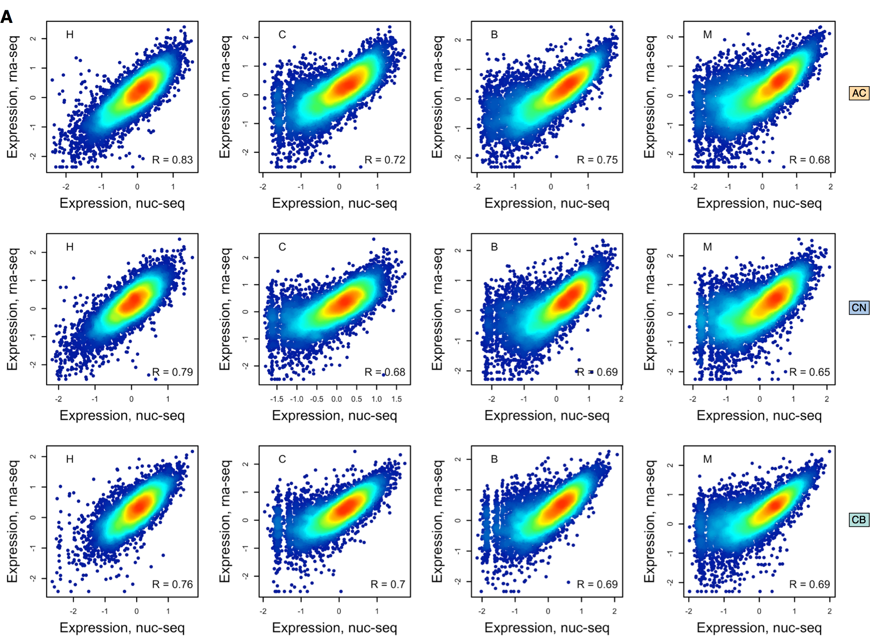

**Supplemental Fig. S21.** Correlation of gene expression levels between RNA-seq and snRNA-seq datasets. Dots represent genes, while colors correspond to the dot density on the plot. All regions and species are shown, as indicated. Correlation coefficients (Pearson’s R) are shown on the plots.

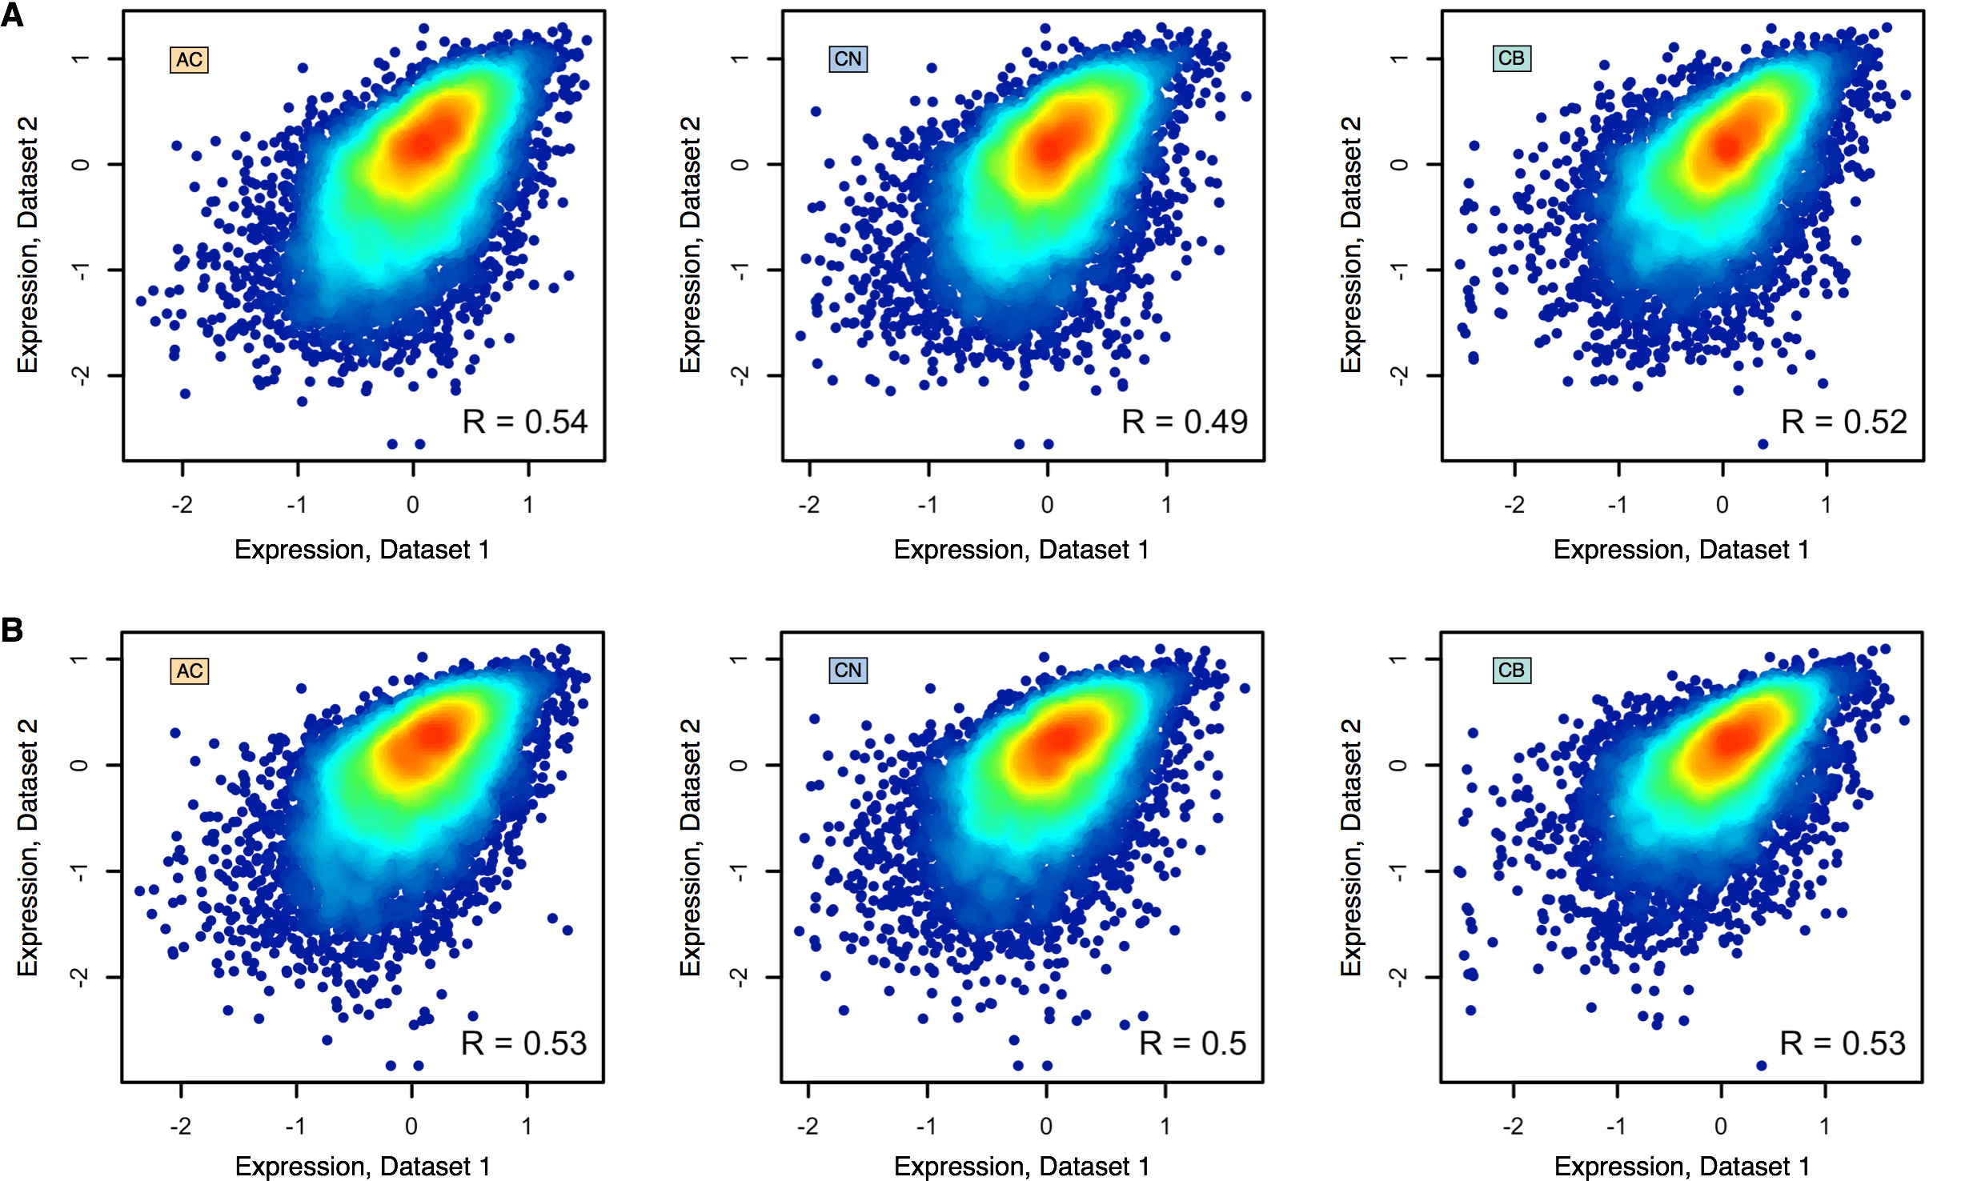

**Supplemental Fig. S22.** Correlation of the averaged gene expression levels between current snRNA-seq data (Dataset 1) and published single-cell RNA-seq data (Dataset 2) [Pollen et al., 2019]. **(A**) The scatter plots showing the gene expression in the primary brain samples from [Pollen et al., 2019] and the expression in each of the three human brain regions of the current, as indicated within panels. Dots represent genes, while colors correspond to the dots’ density. Correlation coefficients (Pearson’s R) are shown within panels. All correlations were significant (p < 0.0001). **(B)** The scatter plots showing the gene expression in the organoid models from [Pollen et al., 2019] and the expression in each of the three human brain regions of the current, as indicated within panels. Dots represent genes, while colors correspond to the dots’ density. Correlation coefficients (Pearson’s R) are shown within panels. All correlations were significant (p < 0.0001).

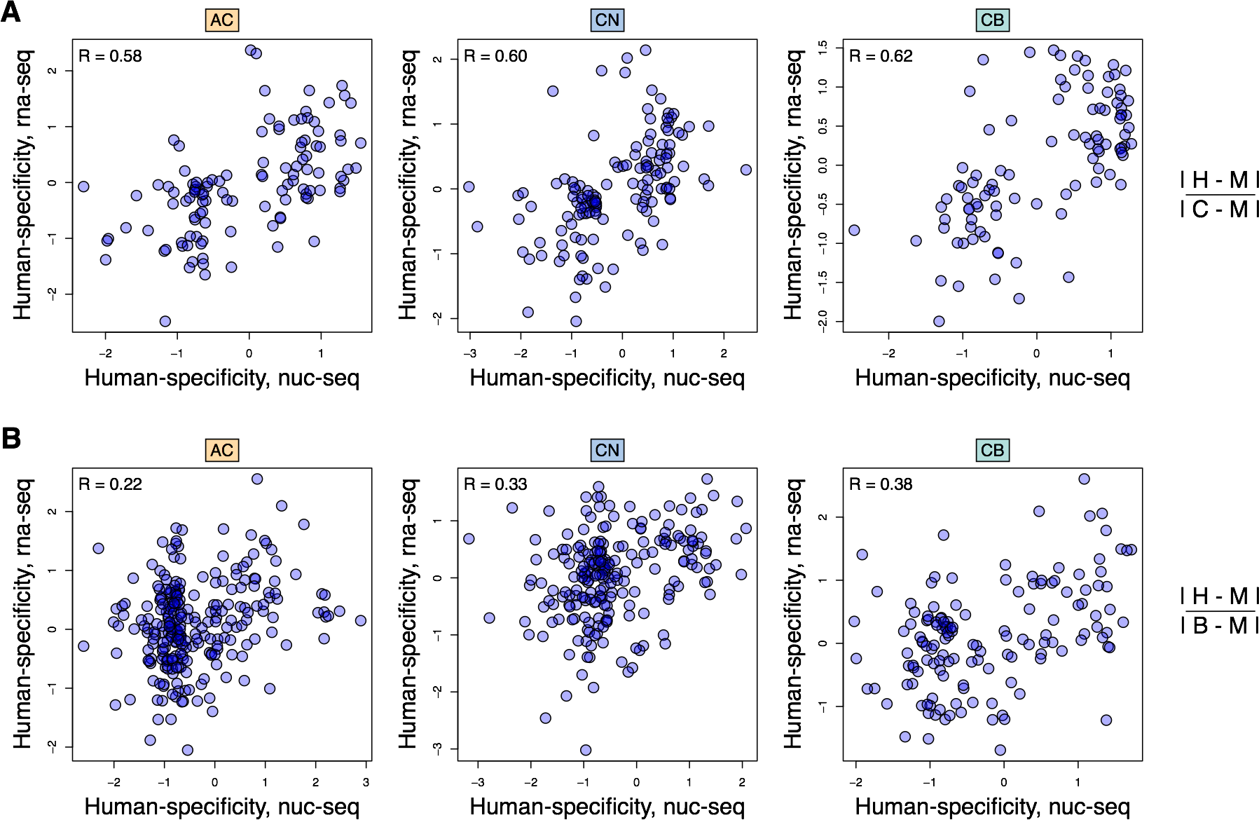

**Supplemental Fig. S23.** Correlation of human-specificity ratios defined as the ratio of human-specific expression differences and chimpanzee-specific (**A**) or bonobo-specific (**B**) expression differences between RNA-seq and snRNA-seq datasets. Dots represent genes. Only genes with high (> 100 times) human/chimpanzee (**A**) or human/bonobo (**B**) gene expression differences in either snRNA-seq or RNA-seq are shown. Three brain regions are shown, as indicated.

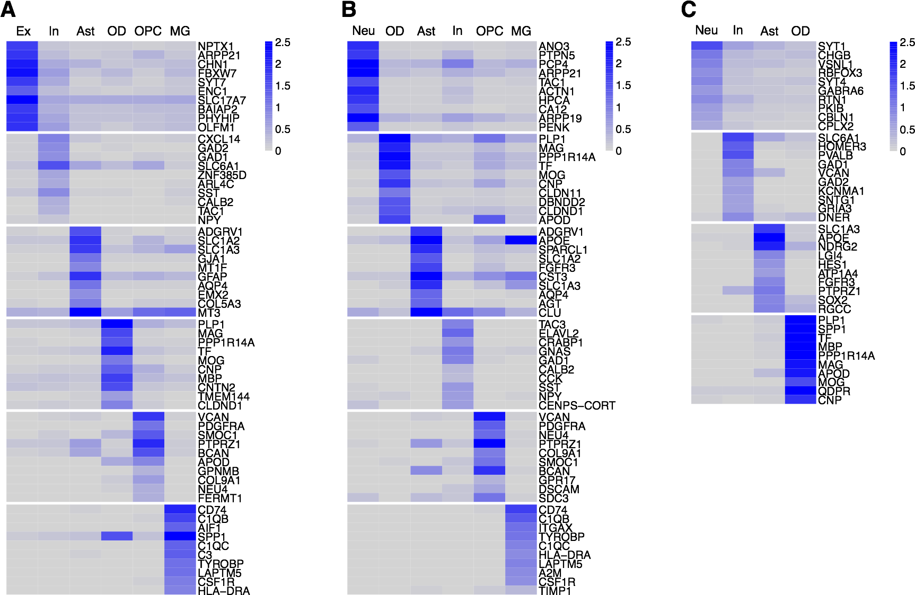

**Supplemental Fig. S24.** Marker genes of *t*-SNE clusters inferred using *Seurat 3.0* package [Stuart et al., 2019]. (**A**) Cingulate anterior cortex (BA24). (**B**) Caudate nucleus. (**C**) Cerebellar gray matter.

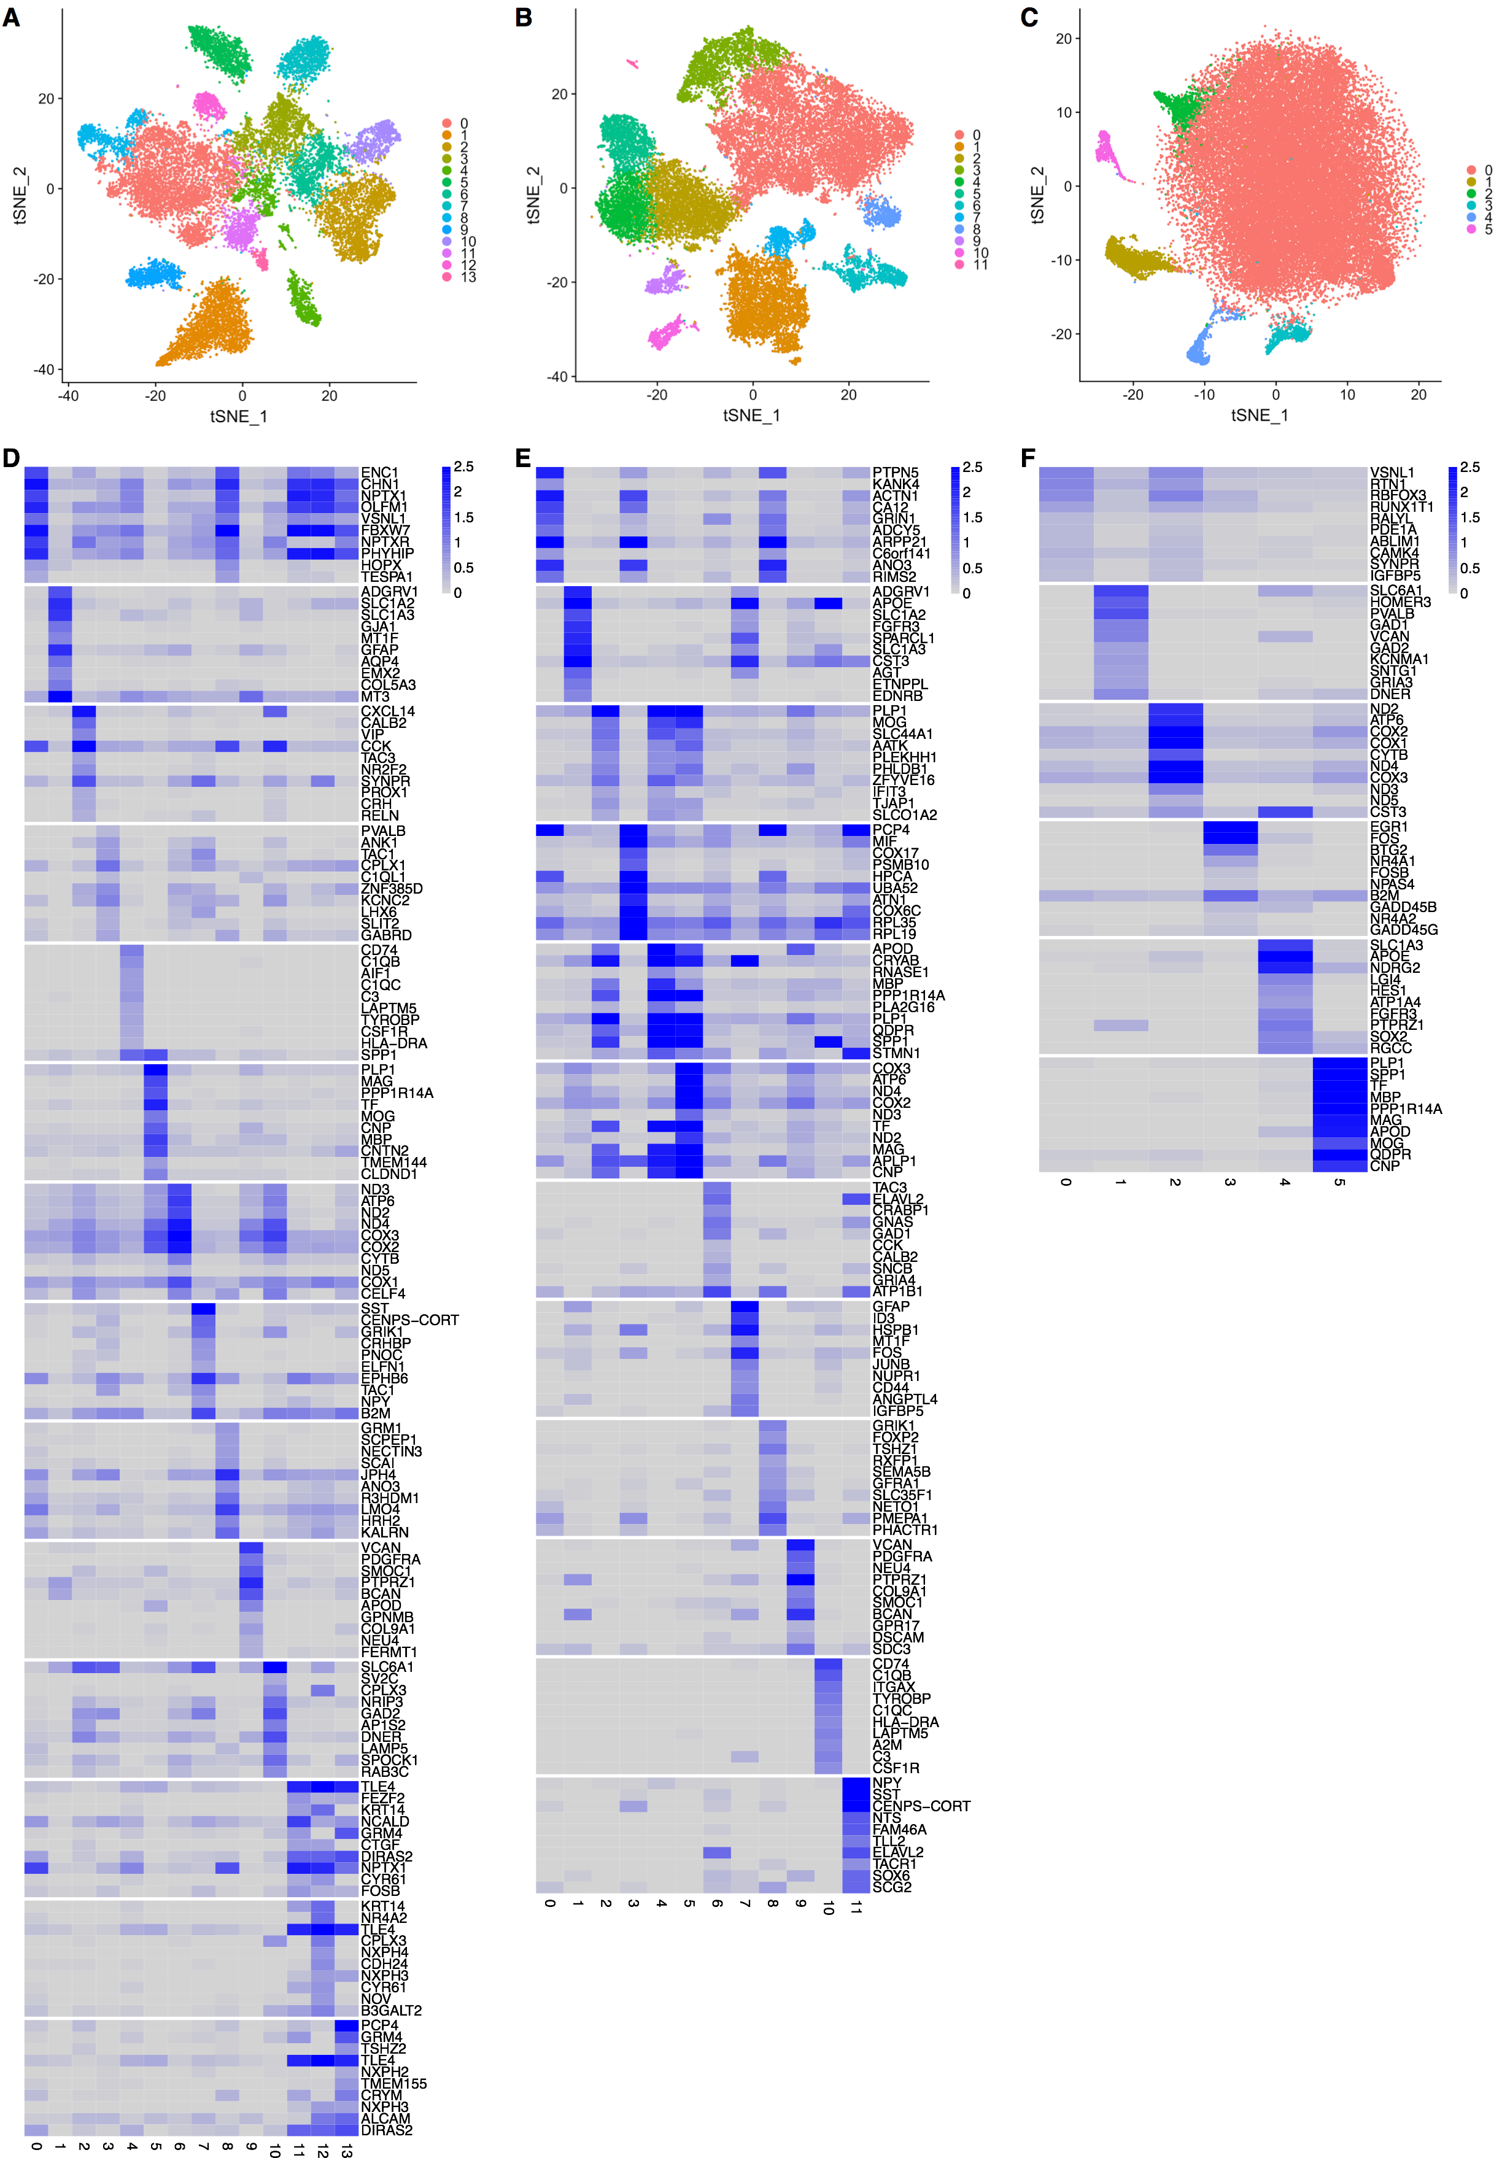

**Supplemental Fig. S25.** Cell type annotation of *t*-SNE clusters in three brain regions. (**A-C**) *t*-SNE plots of nuclei after integration procedure performed using *Seurat 3.0* package [Stuart et al., 2019] in each of the three brain regions: AC (**A**), CN (**B**), and CB (**C**). Colors represent clusters. (**D-F**) Average expression levels of cell type marker genes in each *t*-SNE cluster of AC (**D**), CN (**E**), and CB (**F**). See also Fig. 3.

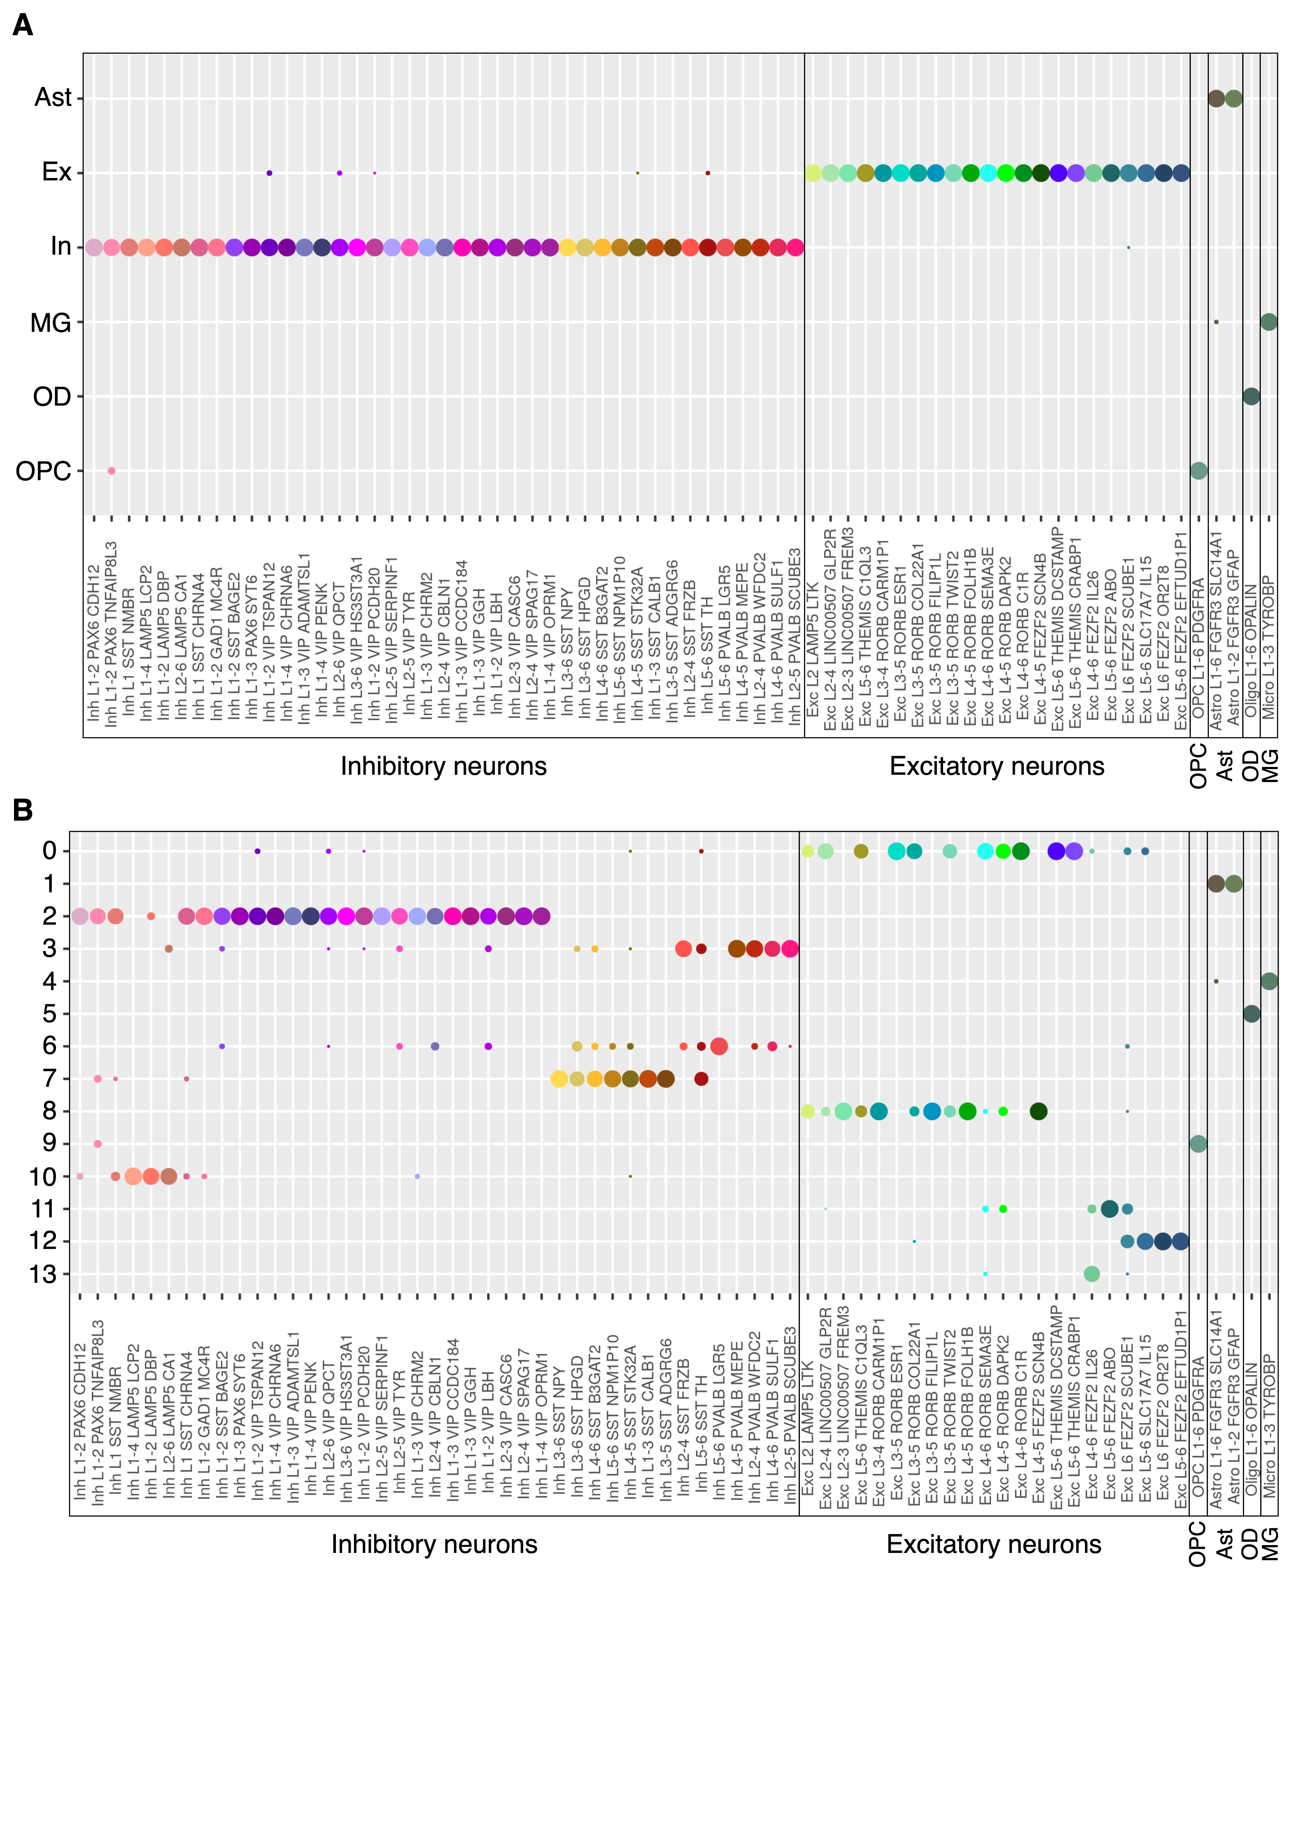

**Supplemental Fig. S26**. Clusters in the AC brain region compared to the cell types defined in [Hodge et al., 2019]. Dot plots show the proportion of each cell type (middle temporal gyrus) that matches clusters in our study, based on a centroid classifier. The size of dots corresponds to middle temporal gyrus cell type proportions that match reported clusters. Black rectangles mark cell types defined in [Hodge et al., 2019] that match our cell types. (**A**) Broad cell classifications. (**B**) Finely resolved clusters.

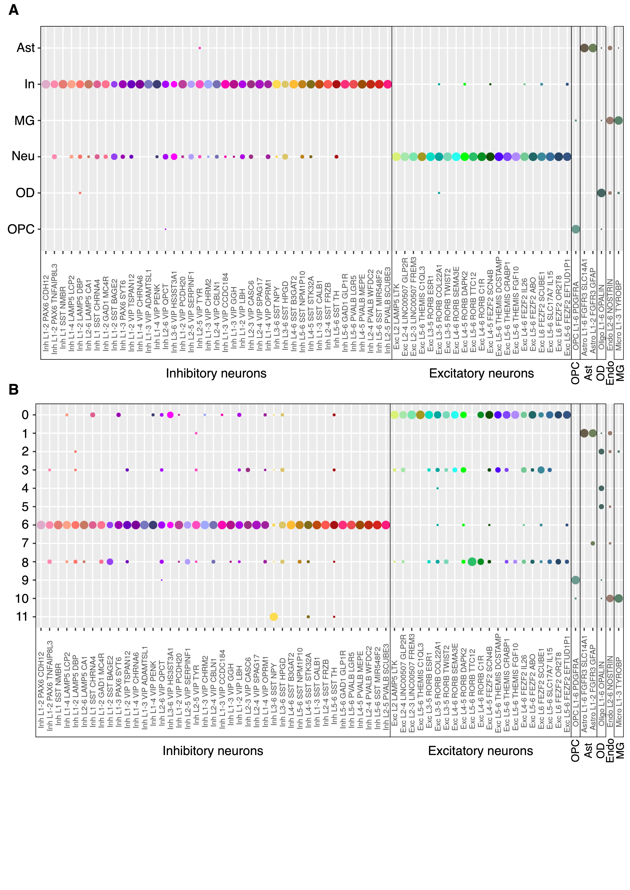

**Supplemental Fig. S27**. Clusters in the CN brain region compared to the cell types defined in [Hodge et al., 2019]. Dot plots show the proportion of each cell type (middle temporal gyrus) that matches clusters in our study, based on a centroid classifier. The size of dots corresponds to middle temporal gyrus cell type proportions that match reported clusters. Black rectangles mark cell types defined in [Hodge et al., 2019] that match our cell types. (**A**) Broad cell classifications. (**B**) Finely resolved clusters.

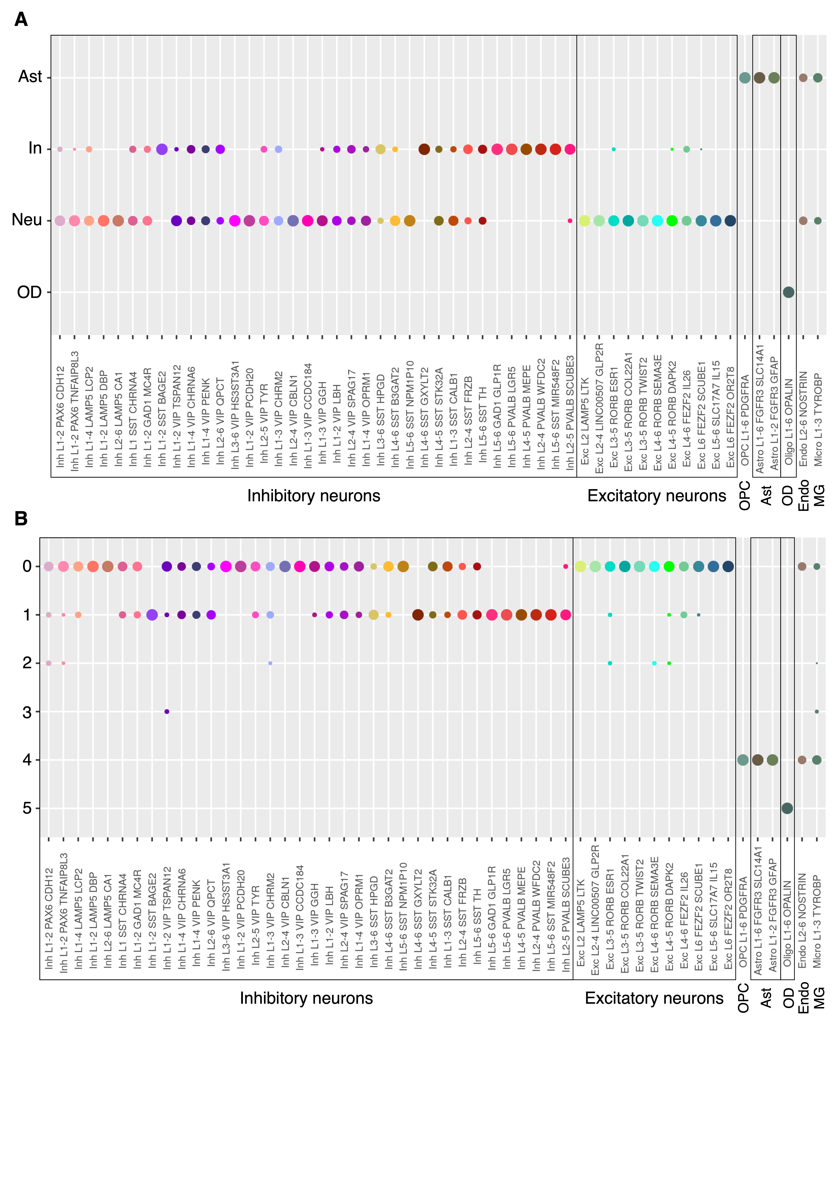

**Supplemental Fig. S28**. Clusters in the CB brain region compared to the cell types defined in [Hodge et al., 2019]. Dot plots show the proportion of each cell type (middle temporal gyrus) that matches clusters in our study, based on a centroid classifier. The size of dots corresponds to middle temporal gyrus cell type proportions that match reported clusters. Black rectangles mark cell types defined in [Hodge et al., 2019] that match our cell types. (**A**) Broad cell classifications. (**B**) Finely resolved clusters.

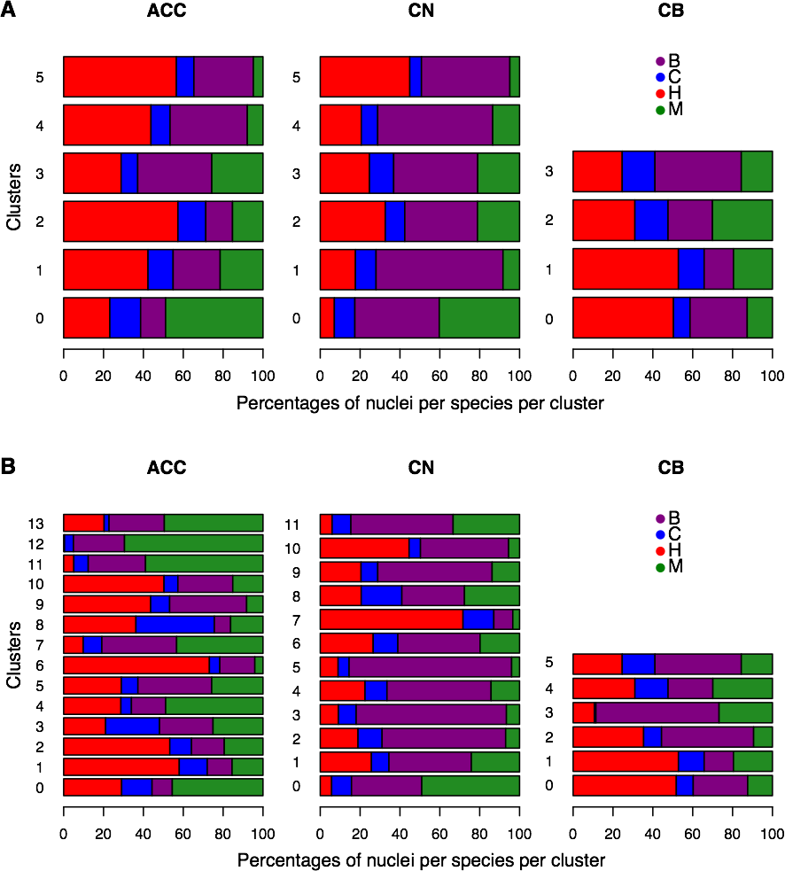

**Supplemental Fig. S29**. Percentages of nuclei per species per cell type in broad cell classifications (**A**) and in finely resolved clusters (**B**).

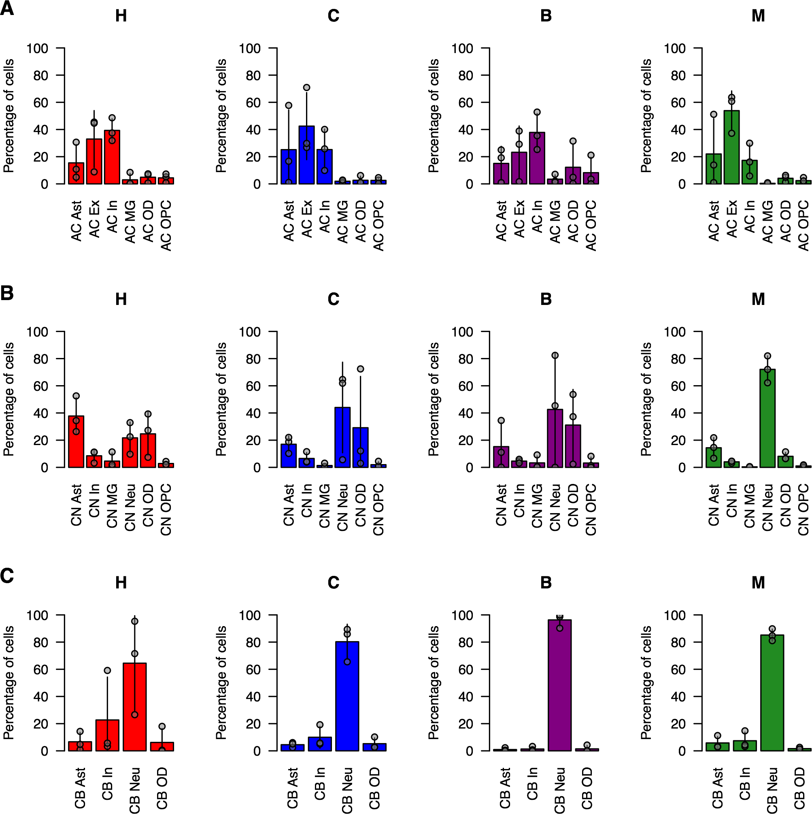

**Supplemental Fig. S30**. Percentages of nuclei per species per cell type in broad cell classifications. Gray circles show percentages in three biological replicates, bars show means calculated among them, and lines represent standard deviations. (**A**) AC. (**B**) CN. (**C**) CB.

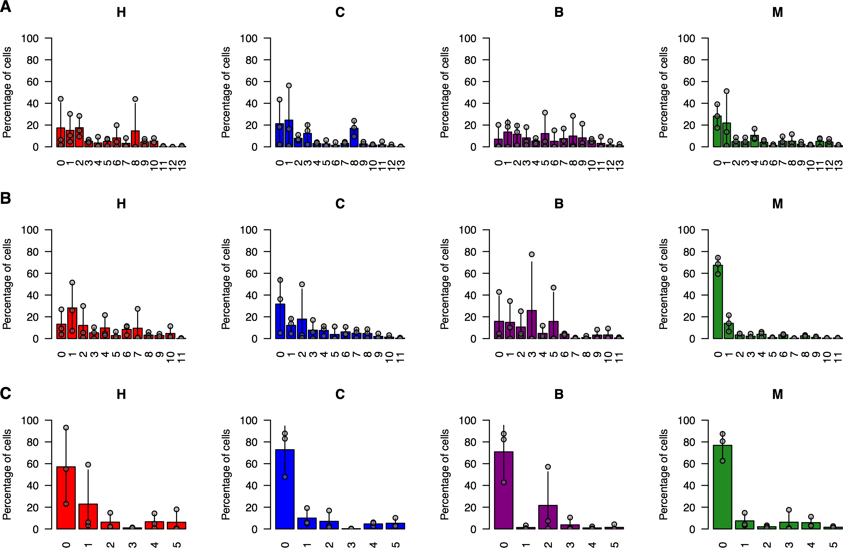

**Supplemental Fig. S31**. Percentages of nuclei per species per cell type in finely resolved clusters. Gray circles show percentages in three biological replicates, bars show means calculated among them, and lines represent standard deviations. (**A**) AC. (**B**) CN. (**C**) CB.

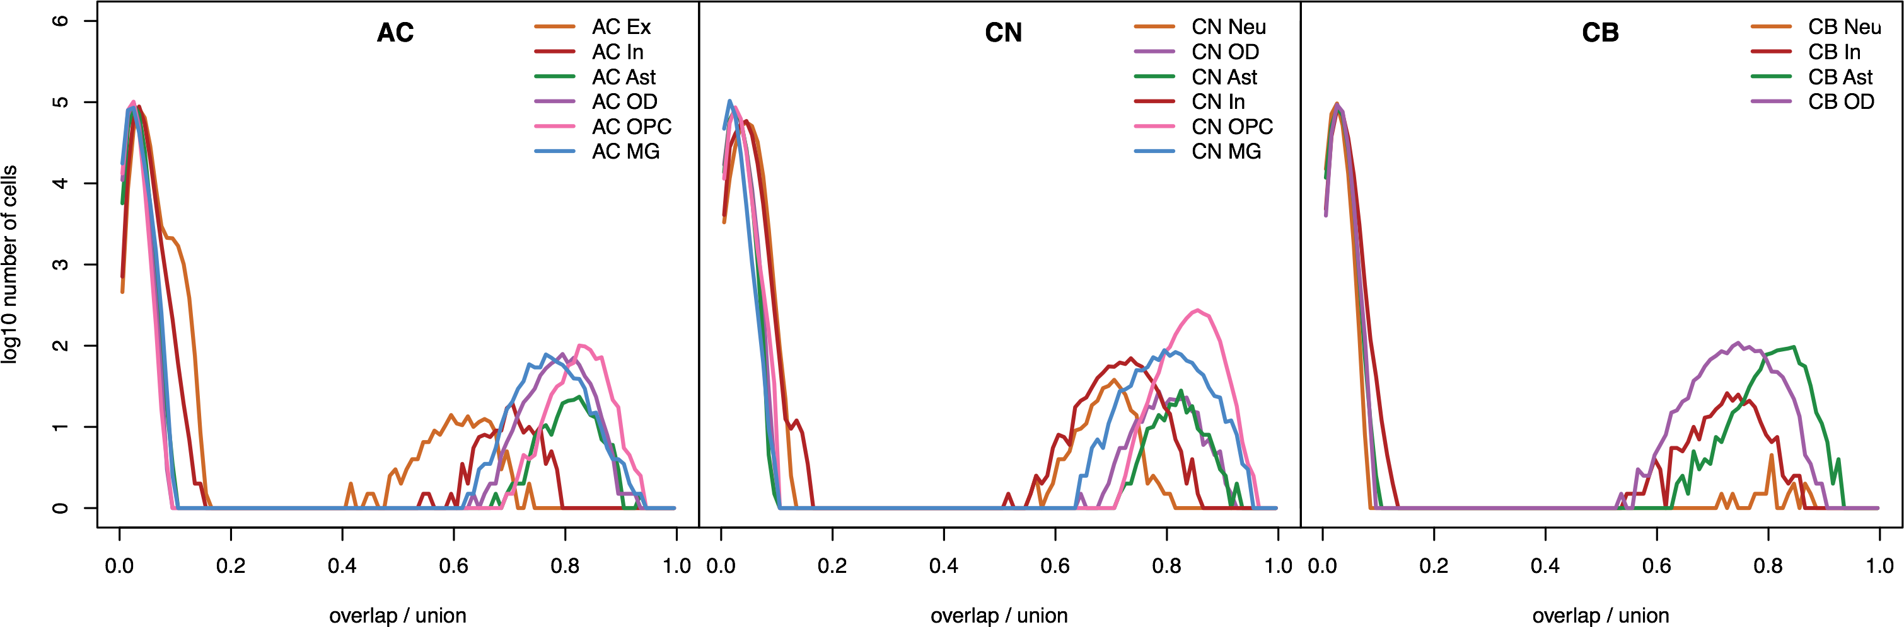

**Supplemental Fig. S32.** Assessment of *t*-SNE cluster heterogeneity in three brain regions by pairwise comparison of human-specific gene lists among 1,000 bootstraps within each cell type and each region. Human-specific genes were classified using 1,000 bootstraps to one nucleus per cell type per region.

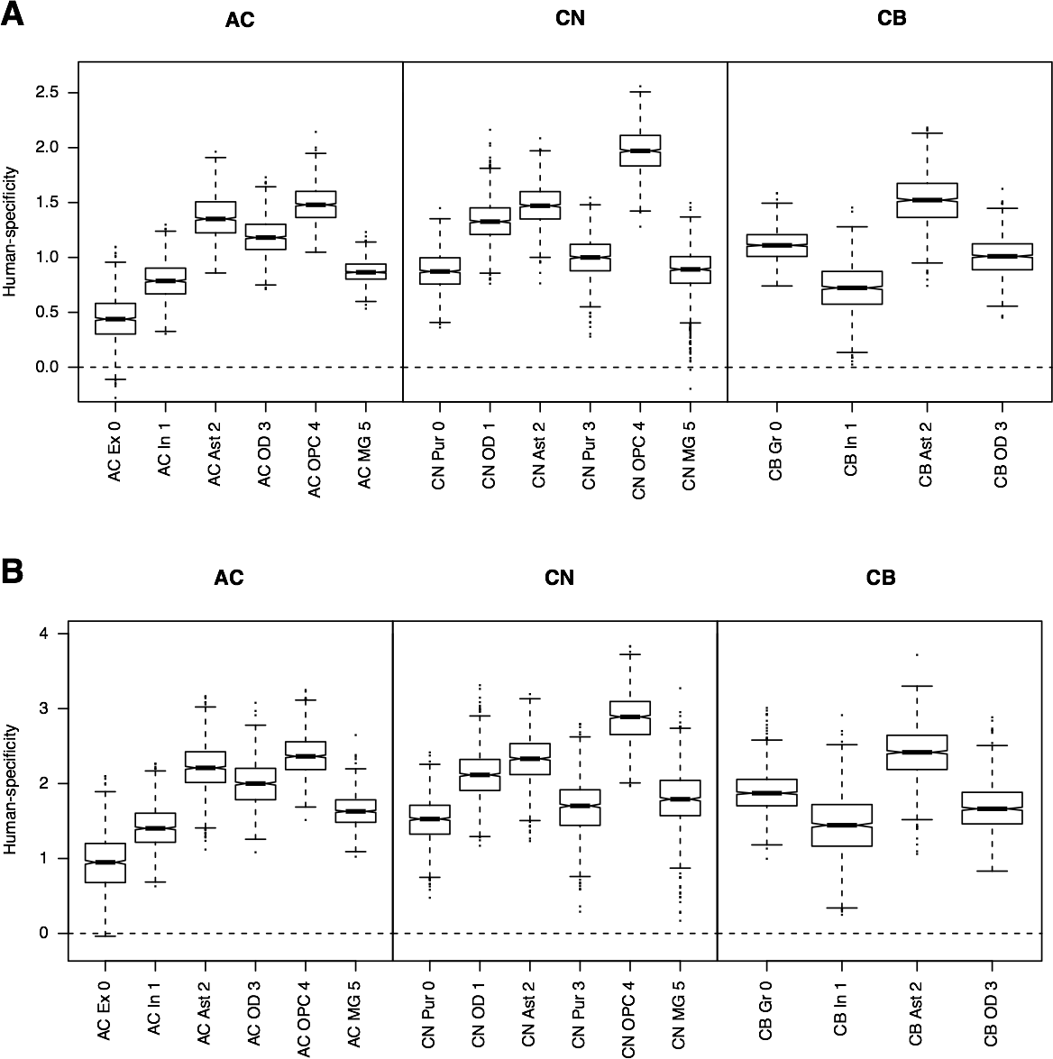

**Supplemental Fig. S33.** Human-specificity ratio calculated within each *t*-SNE cluster in each of the three brain regions. The ratio represents the number of genes with human-specific expression defined using |H-M| / |C-M| > 2 AND |H-M| / |B-M| > 2 criteria, divided by the number of genes with pan-specific expression defined using |C-M| / |H-M| > 2 AND |B-M| / |H-M| > 2 criteria, additionally requiring ( |H-M| > 0 or |C-M| > 0 ) AND ( |H-M| > 0 or |B-M| > 0 ) in both cases. Boxes mark the median and the first and the third quartiles of the distribution, and whiskers extend to the 1.5 interquartile ranges. The cell types are abbreviated as in Fig. 3F. (**A**) Cells down-sampled to 15 cells per species per cell type. (**B**) Cells down-sampled to 5 cells per species per cell type.

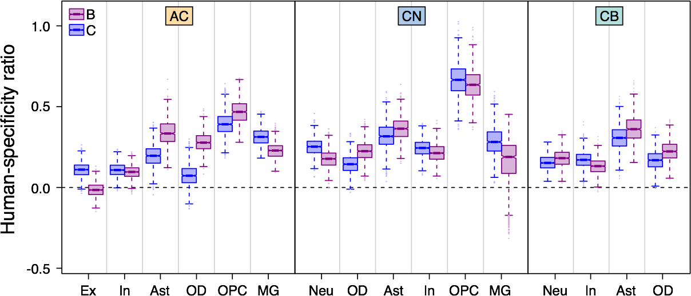

**Supplemental Fig. S34.** Human-specificity ratio calculated within each *t*-SNE cluster in each of the three brain regions. The ratio represents the number of genes with human-specific expression divided by the number of genes with chimpanzee-specific (blue boxplots) or bonobo-specific (purple boxplots) expression. Boxes mark the median and the first and the third quartiles of the distribution, and whiskers extend to the 1.5 interquartile ranges. The cell types are abbreviated as in Fig. 3F. ANOVA was not applied to filter genes in this analysis.

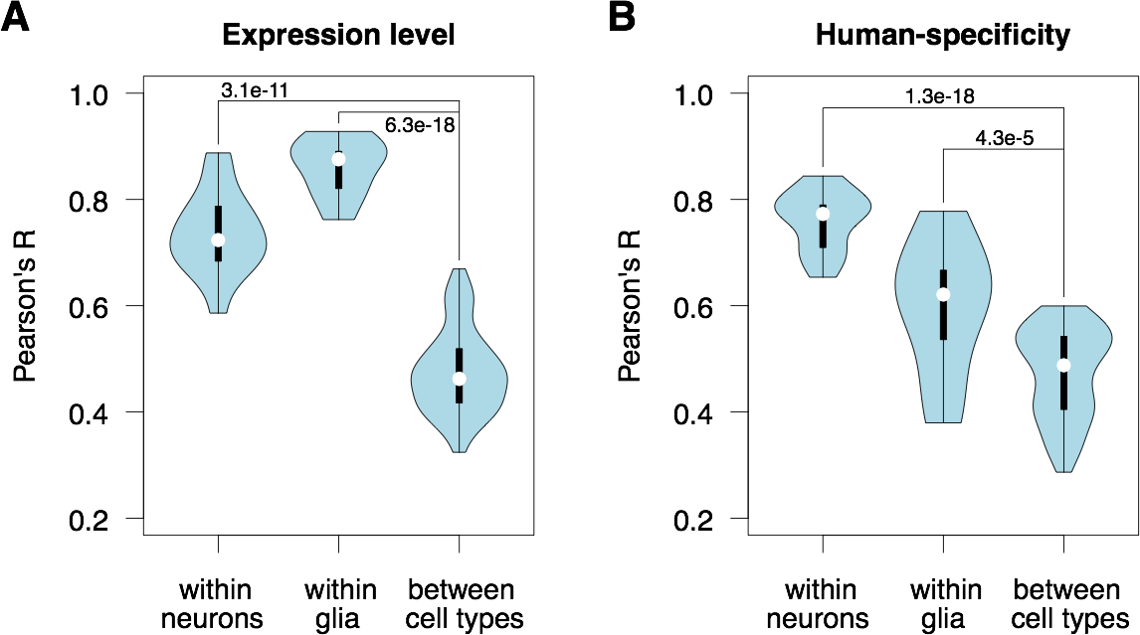

**Supplemental Fig. S35.** Comparison of within cell type correlation to between cell type correlation. (**A**) The expression level similarity based on the average gene expression levels within *t*-SNE clusters in humans. (**B**) The similarity of human-specificity ratio estimates among *t*-SNE clusters calculated based on the comparison to chimpanzee and bonobo (|H-M| / |C-M| > 2 AND |H-M| / |B-M| > 2) in 1,000 bootstraps of cells. Wilcoxon test p-values are shown. For the calculation of correlations within glia, we consider each glial cell type separately. For the calculation of correlations within neurons, we did not consider neuronal subtypes separately.

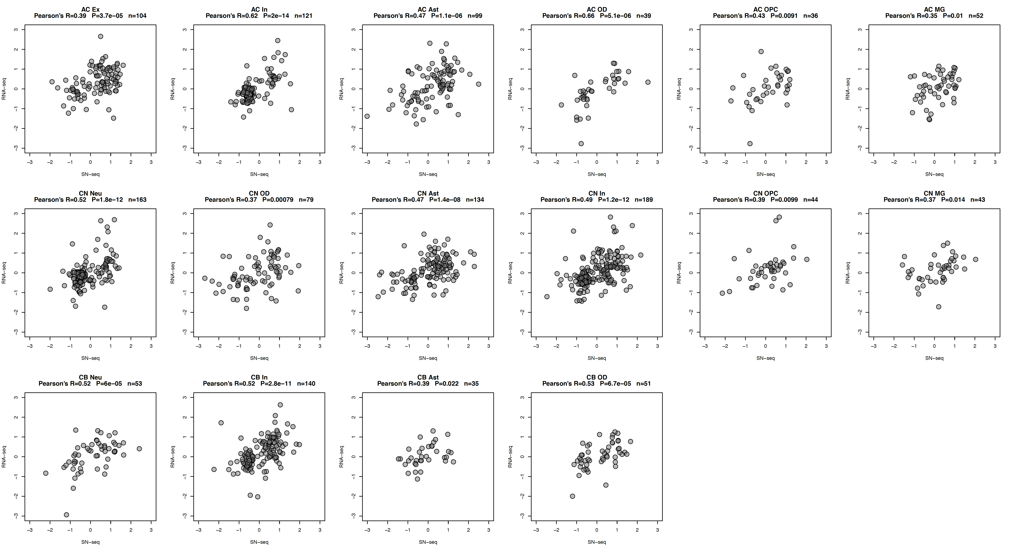

**Supplemental Fig. S36.** Correlation of human-specificity ratios defined as the human-macaque difference relative to chimpanzee-macaque or bonobo-macaque difference between bulk RNA-seq and averaged snRNA-seq datasets for genes passing human-chimpanzee 10-fold difference cutoff in either dataset. Correlations are shown separately for marker genes of each cell type. Marker genes were defined using Seurat with the adjusted p-value cutoff 0.05. Each dot represents a gene. Pearson correlation coefficients shown here are further used in Supplemental Fig. S38.

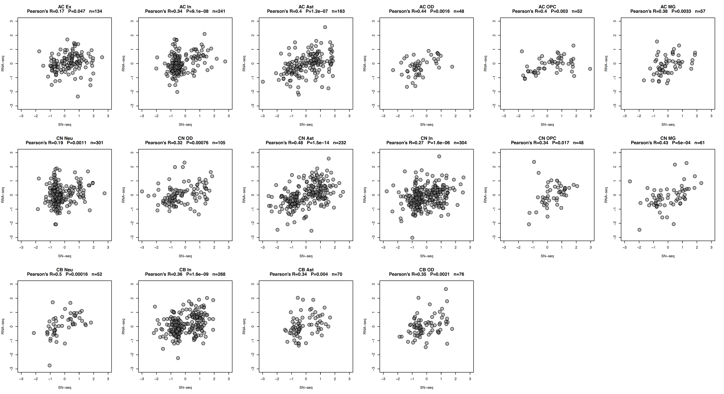

**Supplemental Fig. S37.** Correlation of human-specificity ratios defined as the human-macaque difference relative to chimpanzee-macaque or bonobo-macaque difference between bulk RNA-seq and averaged snRNA-seq datasets for genes passing human-bonobo 10-fold difference cutoff in either dataset. Correlations are shown separately for marker genes of each cell type. Marker genes were defined using *Seurat 3.0* with the adjusted p-value cutoff 0.05. Each dot represents a gene. Pearson correlation coefficients shown here are further used in Supplemental Fig. S38.

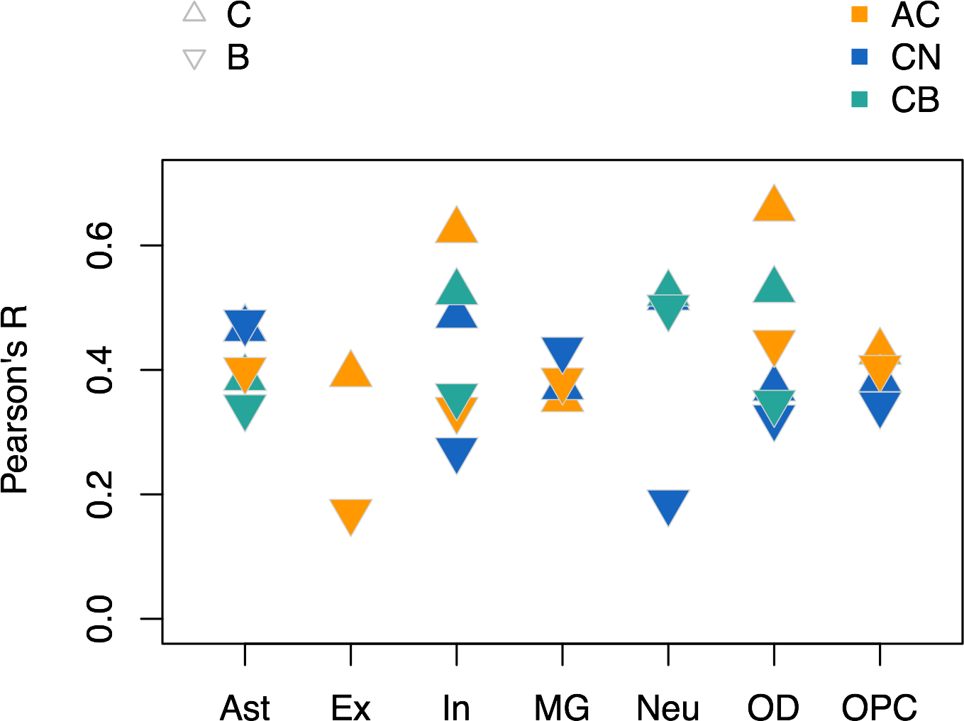

**Supplemental Fig. S38.** Correlation of human-specificity ratios defined as human-macaque difference relative to chimpanzee-macaque (triangles) or bonobo-macaque difference (inverted triangles) between bulk RNA-seq and snRNA-seq datasets for genes preferentially expressed in a specific cell type (Table S5). Colors indicate brain regions. X-axis labels indicate cell types. ANOVA was not applied to filter genes in snRNA-seq dataset.

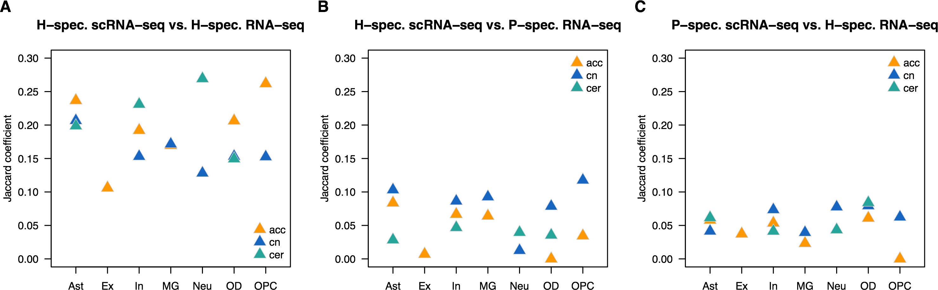

**Supplemental Fig. S39.** Overlap of human-specific or pan-specific genes between bulk RNA-seq and snRNA-seq datasets for genes preferentially expressed in a specific cell type (Table S5). Colors indicate brain regions. X-axis labels indicate cell types. Human-specific genes are defined using |H-M| / |C-M| > 2 AND |H-M| / |B-M| > 2 criteria. Pan-specific genes are defined using |C-M| / |H-M| > 2 AND |B-M| / |H-M| > 2 criteria. We additionally required ( |H-M| > 0 or |C-M| > 0 ) AND ( |H-M| > 0 or |B-M| > 0 ) in this analysis.

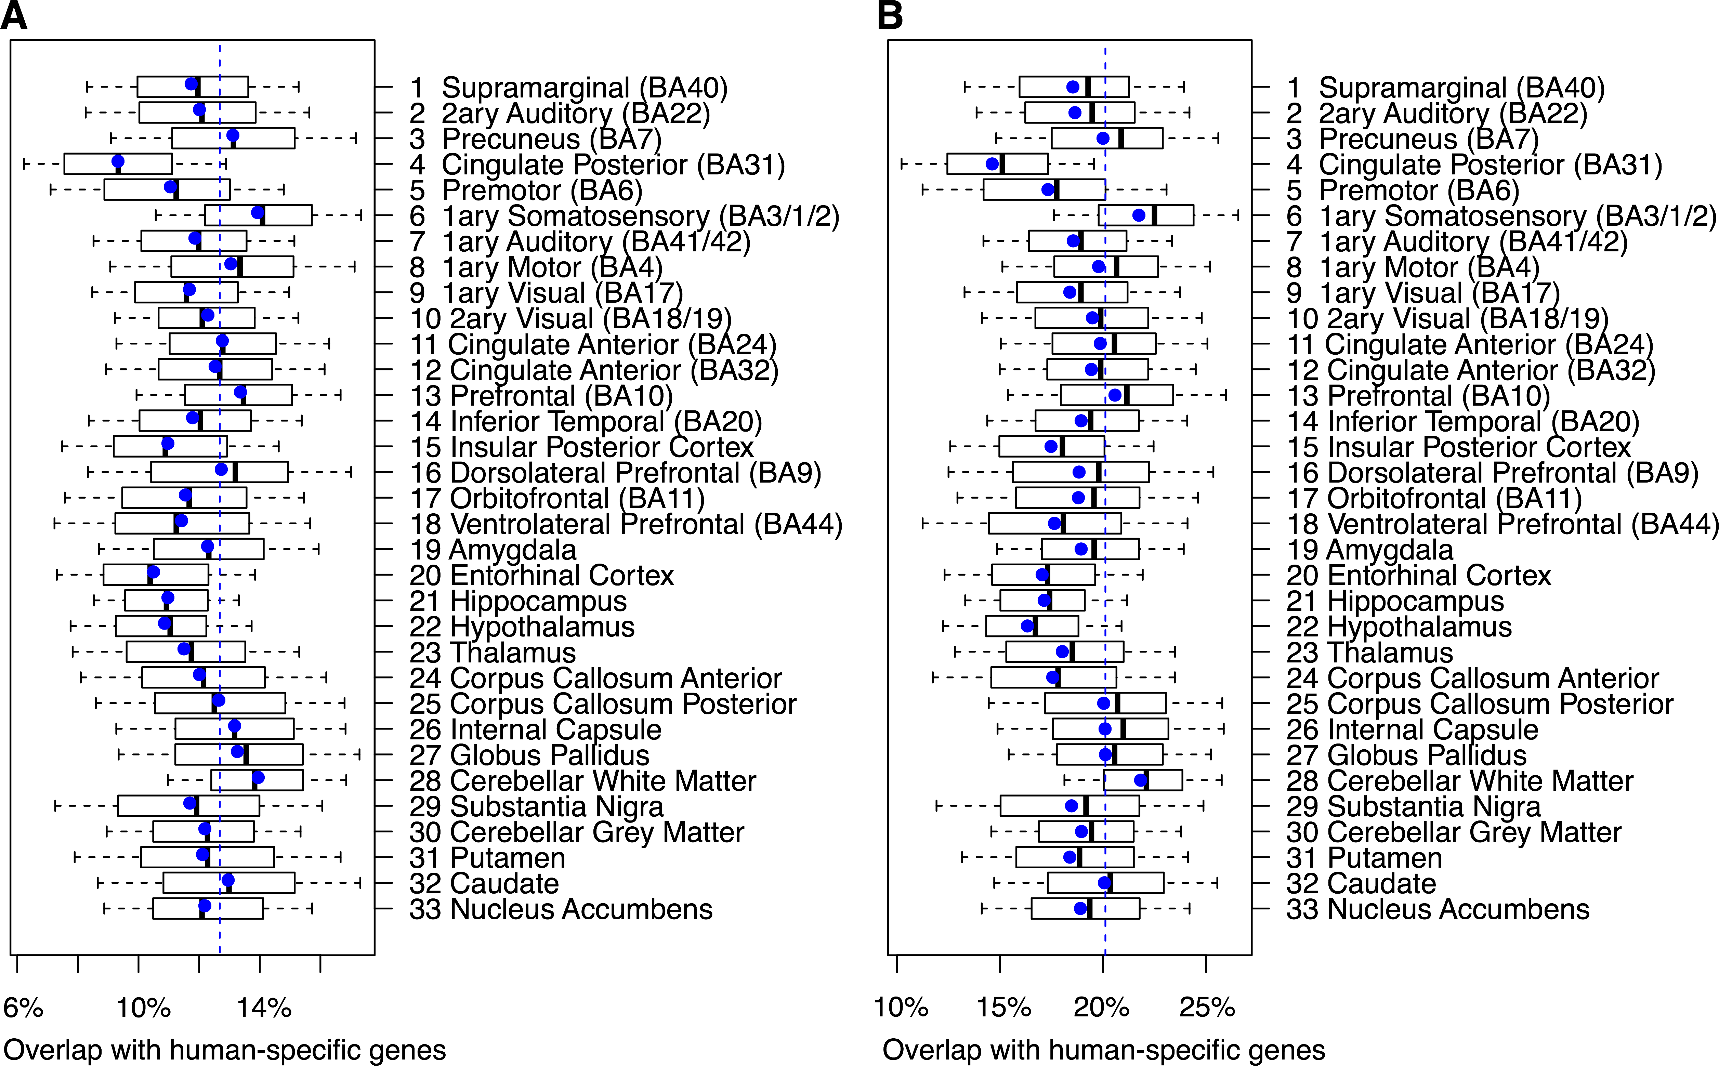

**Supplemental Fig. S40.** Percentages of genes showing human-specific expression in each brain region in bulk RNA-seq dataset overlapping with genes showing human-specific expression in neuronal subtypes in snRNA-seq data. 1,000 random subsamplings to 25 cells per species per cell type. Boxes mark the median and the first and the third quartiles of the distribution, and whiskers extend to the 1.5 interquartile ranges. Blue circles show average values. (A) |H-M| / |C-M| > 2 AND |H-M| / |B-M| > 2 criteria were used, additionally requiring ( |H-M| > 0 or |C-M| > 0 ) AND ( |H-M| > 0 or |B-M| > 0 ). (B) |H-M| / |C-M| > 1 AND |H-M| / |B-M| > 1 criteria were used, additionally requiring ( |H-M| > 0 or |C-M| > 0 ) AND ( |H-M| > 0 or |B-M| > 0 ).

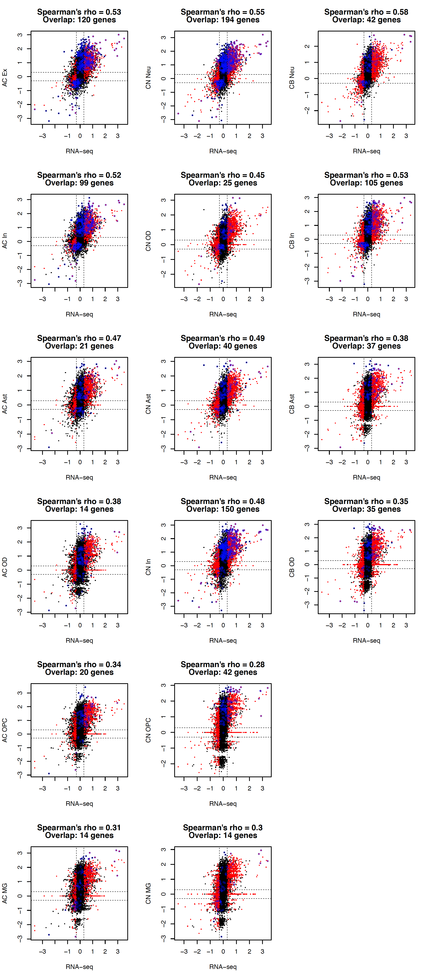

**Supplemental Fig. S41.** Correlation of expression differences separating humans from apes between RNA-seq and snRNA-seq datasets in individual cell types. Dots represent genes. Three brain regions are presented, as indicated. Red dots show > 2-fold difference in Homo/Pan comparison, BH-adjusted p < 0.05, two-sided *t*-test for RNA-seq. Blue circles show > 2-fold difference in Homo/Pan comparison, BH-adjusted p < 0.05, Wilcoxon test implemented in *seurat* for snRNA-seq. Spearman’s correlation coefficients and numbers of genes significant in both bulk RNA-seq and snRNA-seq datasets are shown on plots.

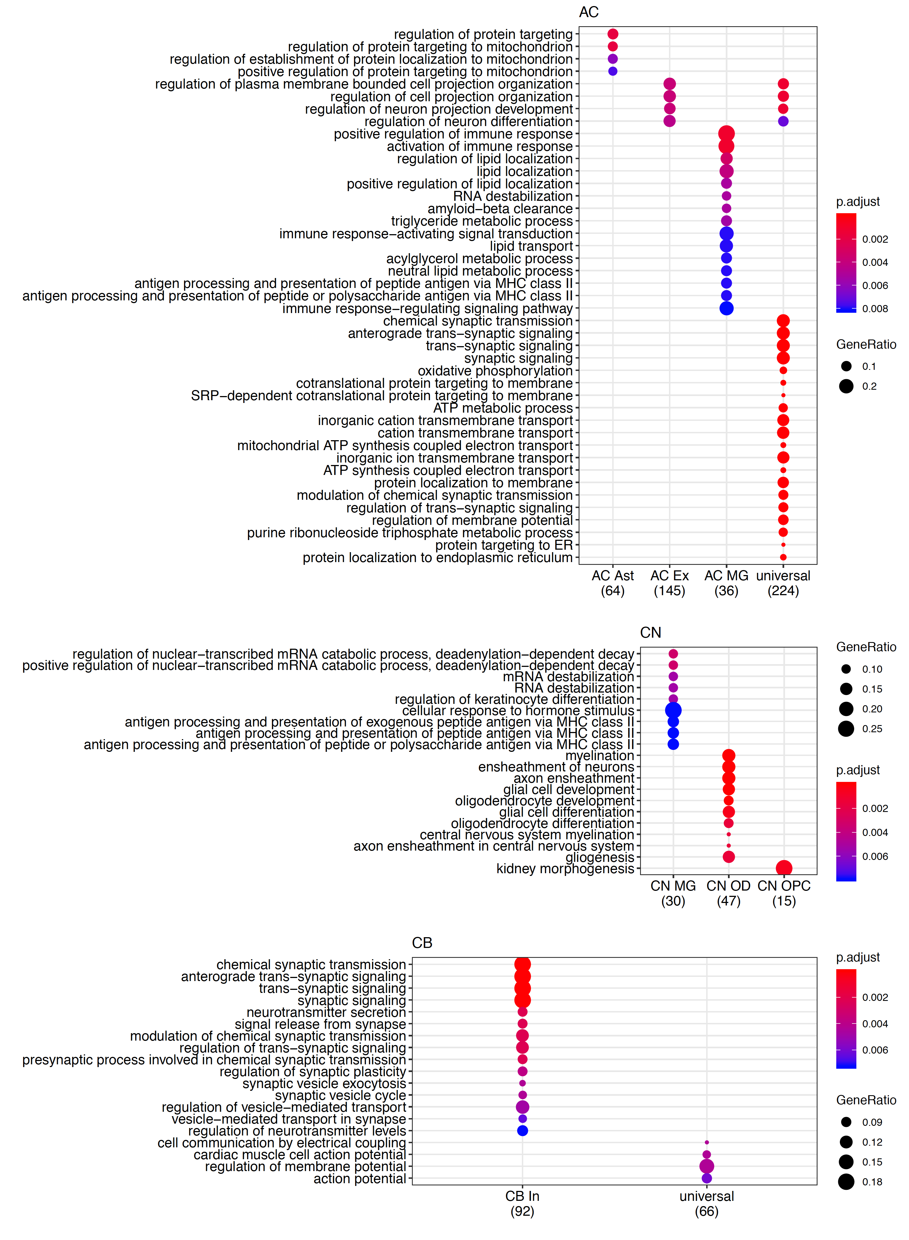

**Supplemental Fig. S42.** Top Gene Ontology (GO) functional terms enriched in the expression differences separating humans from two ape species solely detected by snRNA-seq in three brain regions: anterior cingulate cortex corresponding to Brodmann area 24 (AC), caudate nucleus (CN), Cerebellar gray matter (CB). Size of the circles reflects the proportion of genes within the GO term among genes detected in the brain region using snRNA-seq data (Gene Ratio) [Yu et al., 2012]. Color of the circles indicates the BH-adjusted enrichment p-value.

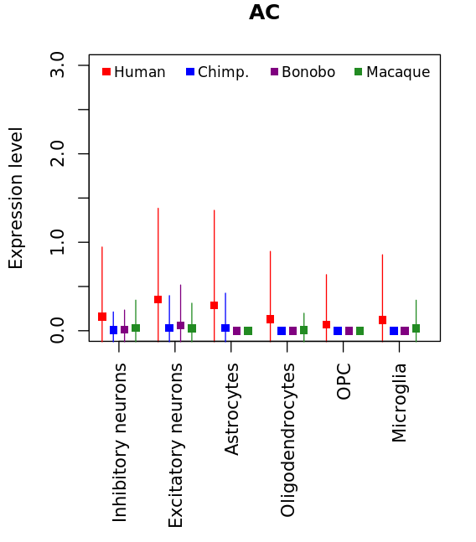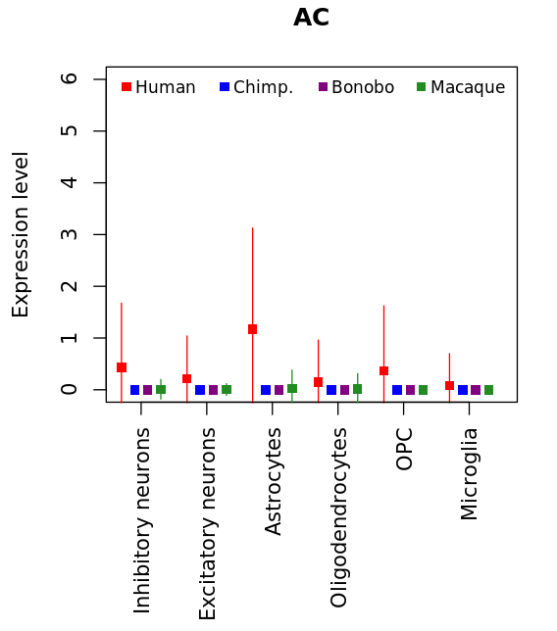

**Supplemental Fig. S43.** Human-specific expression profiles in multiple cell types of the anterior cingulate cortex. (**A**) *NFAT5* gene expression in inhibitory and excitatory neurons, astrocytes, oligodendrocytes, OPC, and microglia in the human, chimpanzee, bonobo, and macaque. (**B**) *MSI2* gene expression in inhibitory and excitatory neurons, astrocytes, oligodendrocytes, OPC, and microglia in the human, chimpanzee, bonobo, and macaque.

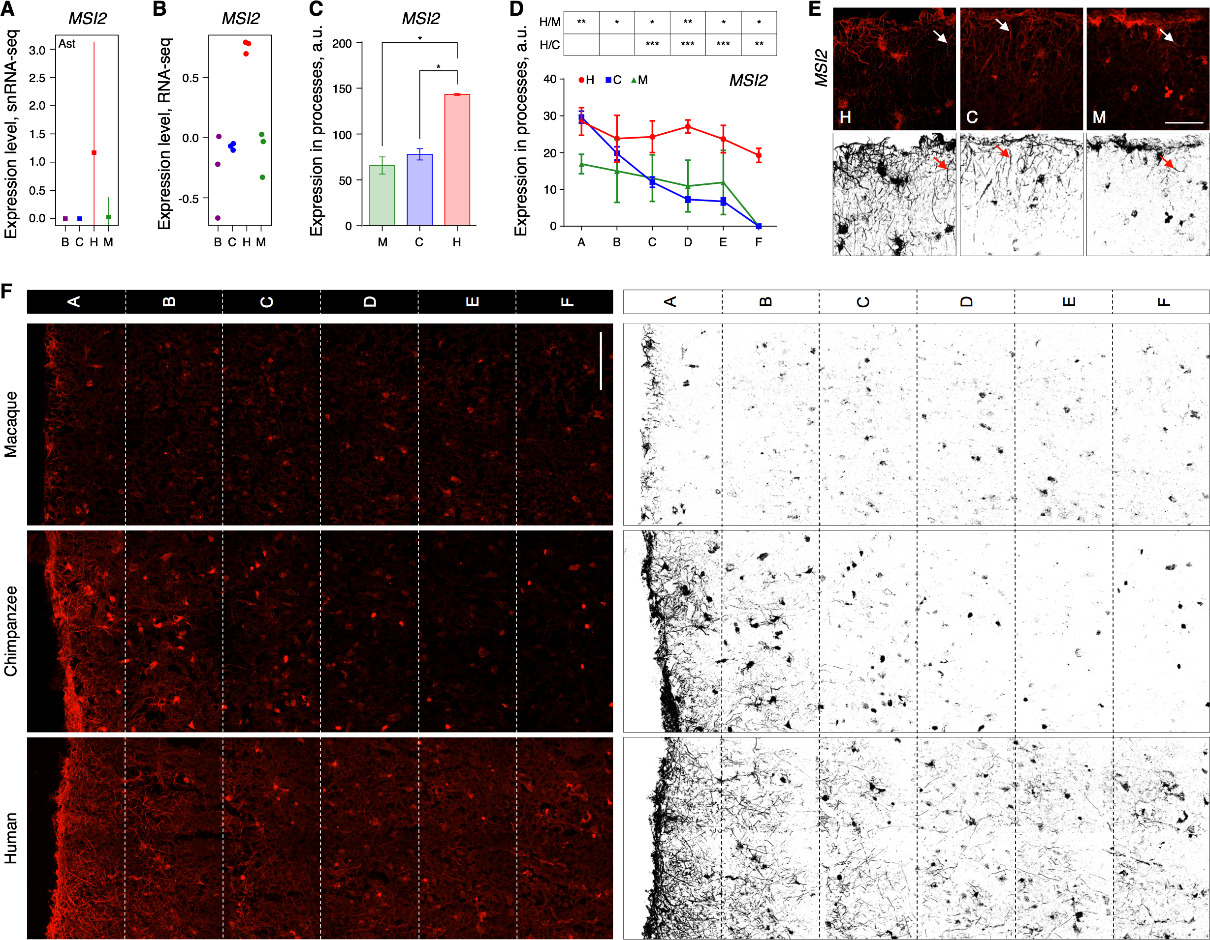

**Supplemental Fig. S44.** Gene expression differences detected by IHC in *MSI2*. **(A)** The mean log10 transformed expression level of *MSI2* mRNA in AC astrocytes (squares), and the standard deviation of the mean (vertical lines). **(B)** The log10 transformed expression levels of *MSI2* mRNA in bulk AC data. Circles indicate individual samples. **(C)** Average fluorescent intensities of MSI2 IHC signal in the astrocytic processes of macaques, chimpanzees, and humans across cortical layers and (**D**) at different cortical depth. Error bars show the standard deviation of the mean. *** – p<0.0005, ** – p<0.0005, * – p<0.05 (two-sided *t*-test, Holm-Sidak correction). H/C – human-chimpanzee comparison. H/M – human-macaque comparison. Symbols indicate cortical sections located at increasing depth, depicted in panel F. (**E**) IHC (upper panels) and its binarized representation (lower panels) of MSI2 protein in the uppermost layer of AC sections. Arrows indicate astrocytic processes. Scale bar 100 µm. (**F**) Immunostaining (left panels) and its binarized representation (right panels) of MSI2 protein in the three upper layers of AC sections in macaques, chimpanzees, and humans (see also Supplemental Fig. S45-S49 for GFAP and DAPI staining of these sections). Sections A-F indicate segmentation areas used in the analysis presented in panel D. Scale bar 100 µm.

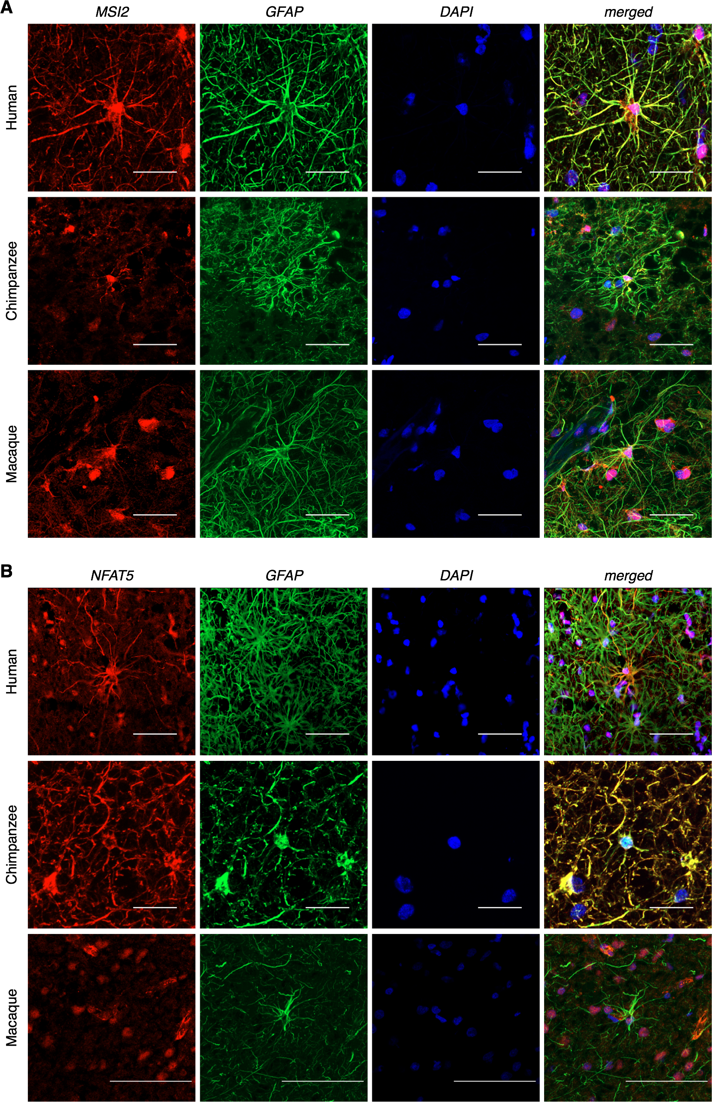

**Supplemental Fig. S45.** Immunostaining of MSI2, NFAT5, GFAP proteins, as well as DAPI staining, in layer 1 of the human, chimpanzee, and macaque AC sections. (A) MSI2, musashi RNA binding protein 2 (red), GFAP, glial fibrillary acidic protein (green), DAPI, 4′,6-diamidino-2-phenylindolen (blue). Scale bar 50 µm. (B) NFAT5, nuclear factor of activated T-cells 5 (red), GFAP, glial fibrillary acidic protein (green), DAPI, 4′,6-diamidino-2-phenylindole (blue). Scale bar 50 µm.

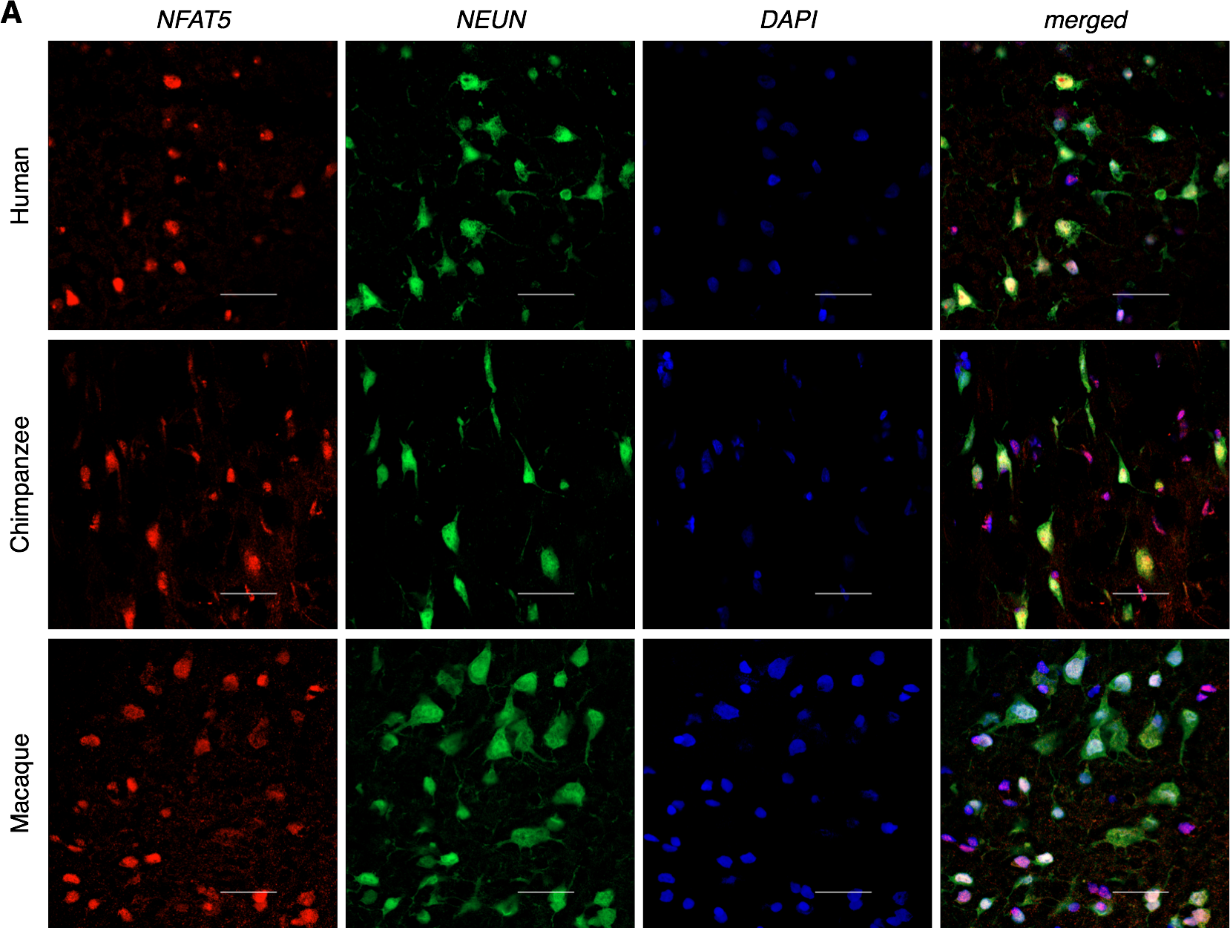

**Supplemental Fig. S46.** Immunostaining of MSI2, NFAT5, NeuN proteins, as well as DAPI staining, in layer 3 of the human, chimpanzee, and macaque AC sections. (A) NFAT5, nuclear factor of activated T-cells 5 (red), NeuN, a neuronal marker (green), DAPI, 4′,6-diamidino-2-phenylindole (blue). Scale bar 50 µm.

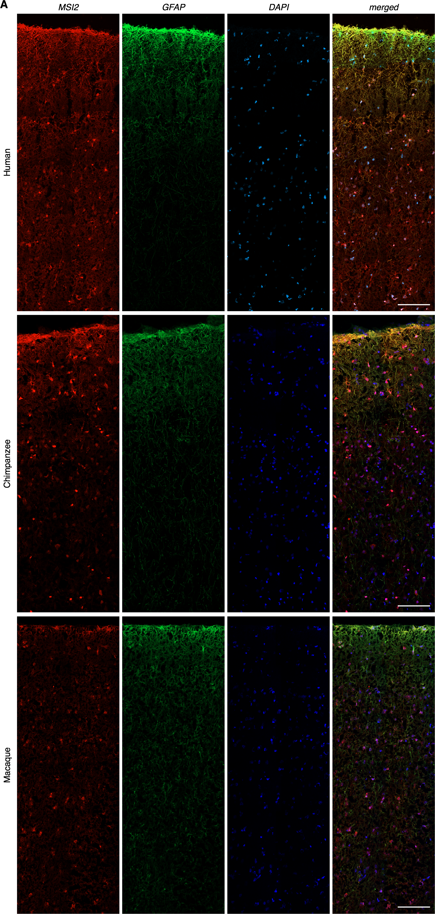

**Supplemental Fig. S47.** Immunostaining of MSI2 and GFAP proteins, as well as DAPI staining, in layers 1-3 of the human, chimpanzee, and macaque AC sections. MSI2, musashi RNA binding protein 2 (red), GFAP, glial fibrillary acidic protein (green), DAPI, 4′,6-diamidino-2-phenylindolen (blue). Scale bar 100 µm.

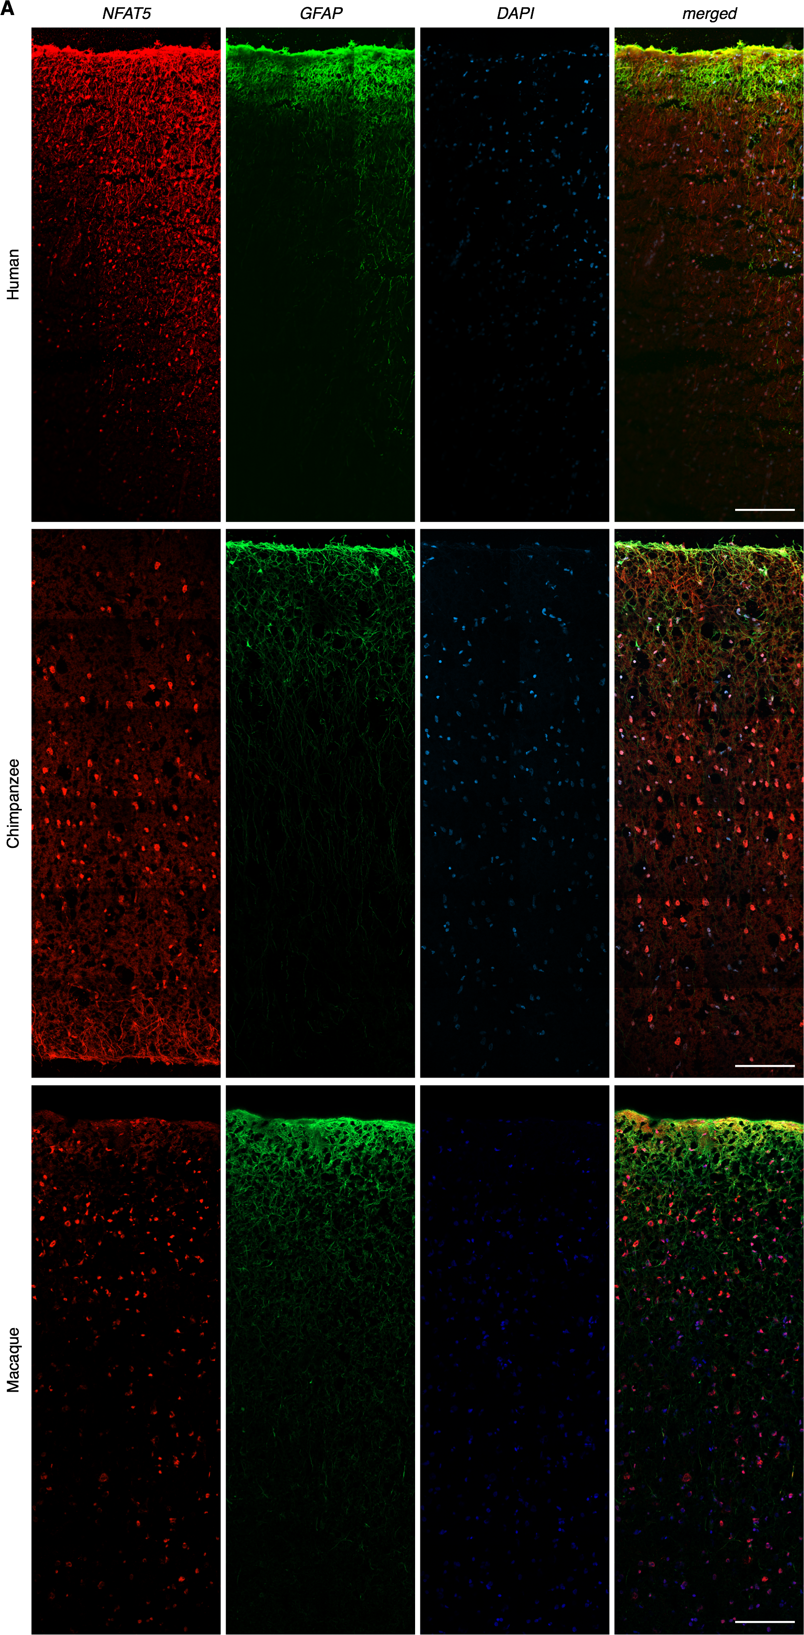

**Supplemental Fig. S48.** Immunostaining of NFAT5 and GFAP proteins, as well as DAPI staining, in layers 1-3 of the human, chimpanzee, and macaque AC sections. NFAT5, nuclear factor of activated T-cells 5 (red), GFAP, glial fibrillary acidic protein (green), DAPI, 4′,6-diamidino-2-phenylindole (blue). Scale bar 100 µm.

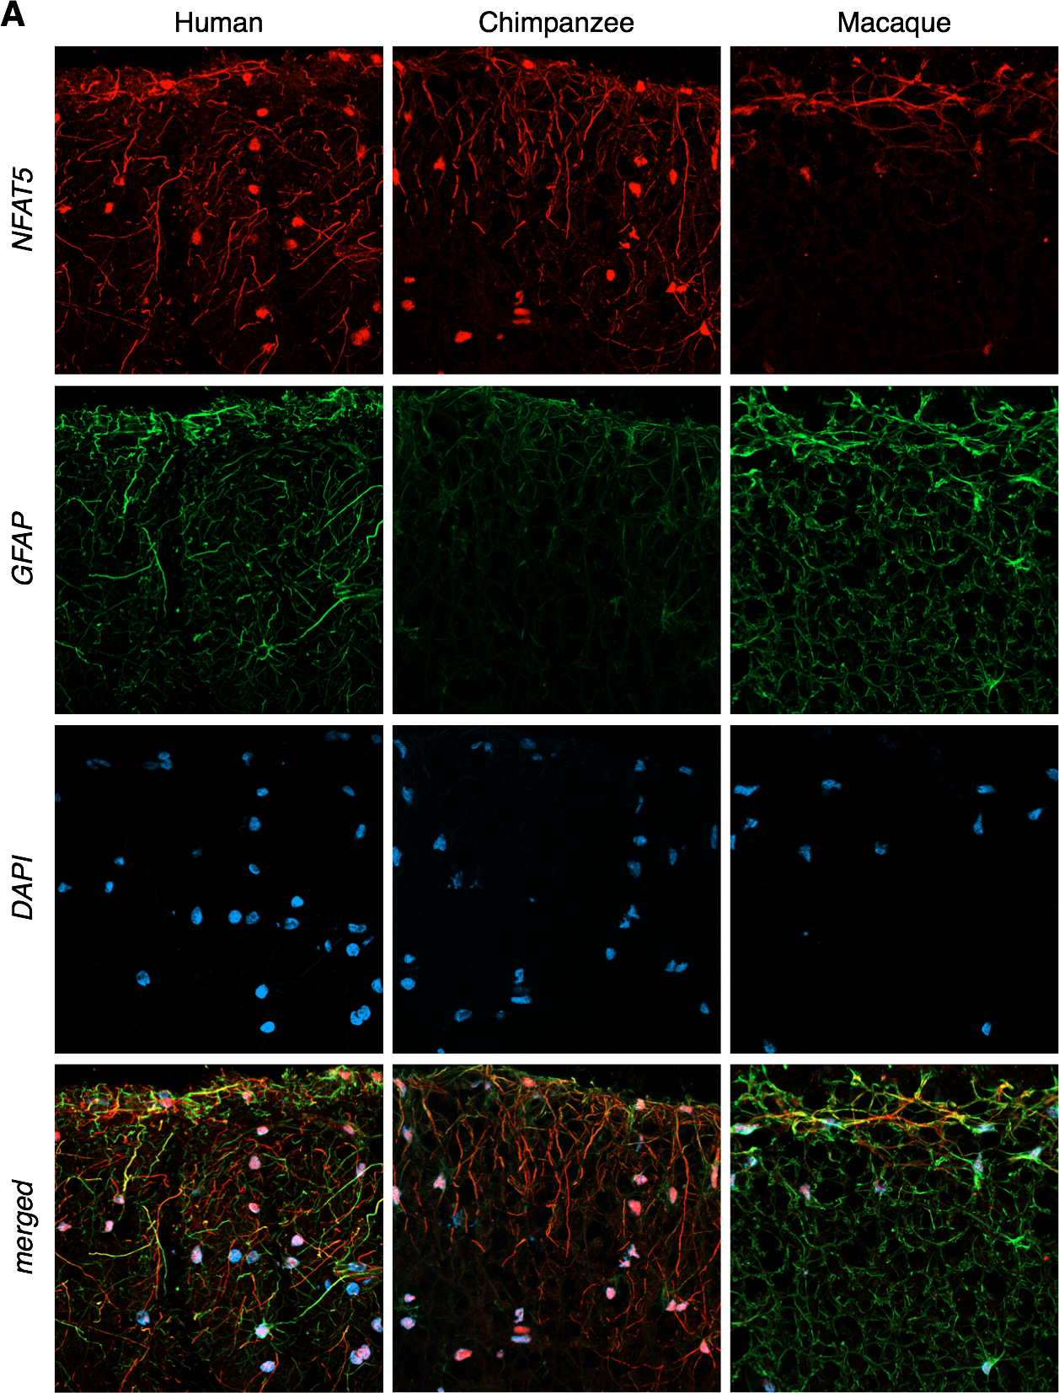

**Supplemental Fig. S49.** Immunostaining of NFAT5 and GFAP proteins, as well as DAPI staining, in the uppermost layer of the human, chimpanzee, and macaque AC sections. NFAT5, nuclear factor of activated T-cells 5 (red), GFAP, glial fibrillary acidic protein (green), DAPI, 4′,6-diamidino-2-phenylindole (blue). See also Fig. 7.

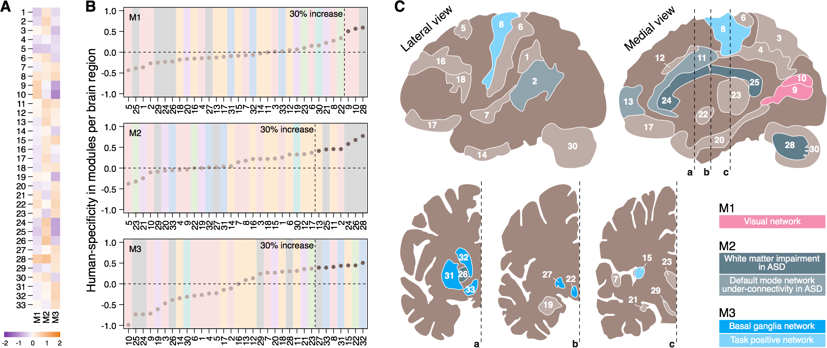

**Supplemental Fig. S50.** Modules of human-specific genes. (**A**) Modules of genes clustered based on their human-specificity ratio. Colors represent the average human-specificity ratio in each brain region. (**B**) Brain regions ordered by the average human-specificity ratio of genes in three modules. Circles show the average human-specificity ratio within a region. Darker circles mark brain regions with human-specificity ratio > 1.3-fold. Background colors represent clusters of brain regions defined in Fig. 1G. (**C**) Brain regions with top human-specificity expression ratios (human-specificity ratio > 1.3) in three modules colored according to their functional network identity. M1 regions included both primary and secondary visual cortices – the regions involved in the visual network [Washington et al., 2014]. M2 regions included all four analyzed white matter regions and three cortical regions representing the default mode network and impaired in autism spectrum disorder (ASD) [Greicius et al., 2003; Shukla et al., 2010; Washington et al., 2014; Maximo and Kana, 2019]. M3 regions mainly included subcortical brain areas, such as the caudate nucleus, putamen, nucleus accumbens, hypothalamus, globus pallidus, as well as two neocortical regions, - components of the basal ganglia and task-positive networks [Maximo and Kana, 2019; Patel et al., 2015].

**Supplemental Fig. S51.** Western blot showing immunoreaction of anti-NFAT5 (Novus Biologicals NB120-3446) and anti-MSI2 (Novus Biologicals NBP2-45837). Note that proteins with similar molecular weights are detected in macaque and chimpanzee brains for each antibody.

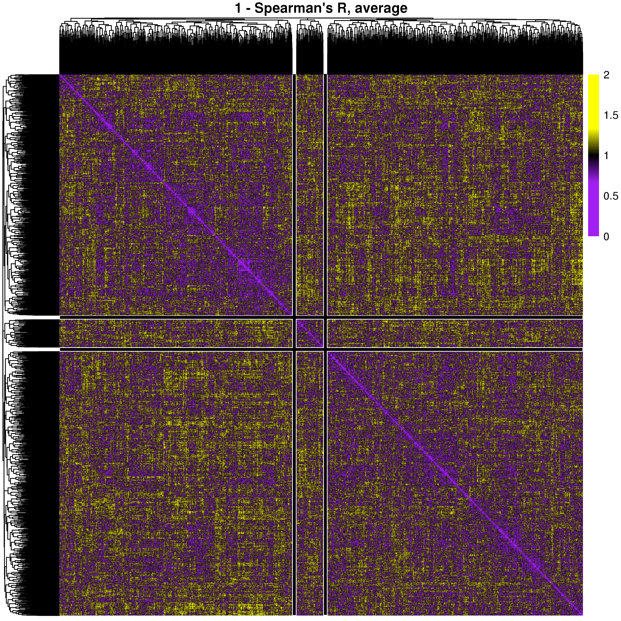

**Supplemental Fig. S52.** Genes with expression differences among species that varied significantly depending on the brain region (rows and columns) clustered using UPGMA method. Colors correspond to the distance metric: one minus Spearman’s correlation coefficient. Three modules are separated by the black lines.

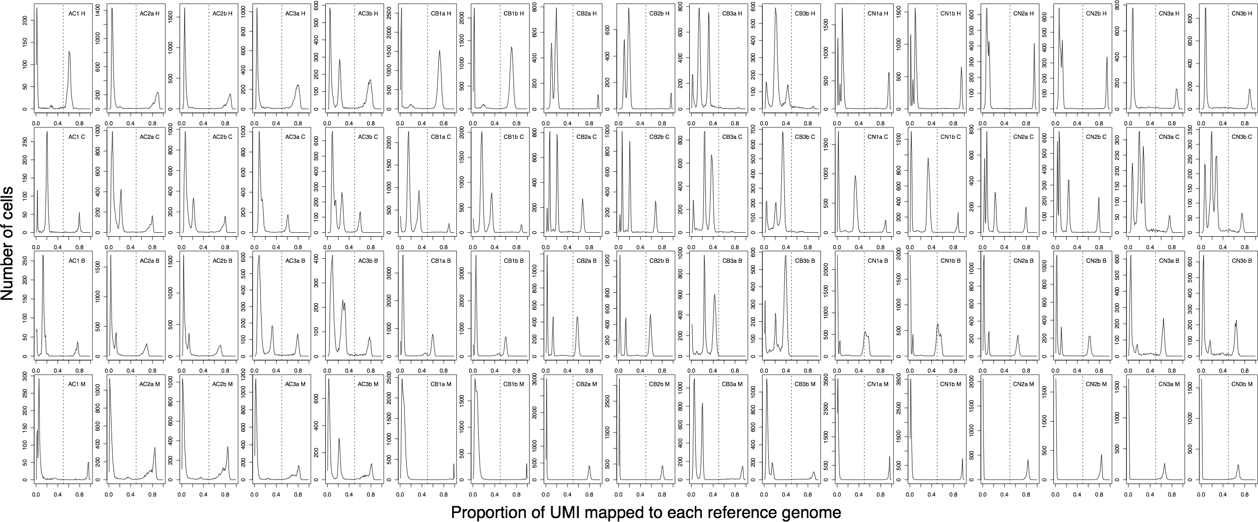

**Supplemental Fig. S53.** Distributions of proportions of UMI mapped to one species per nucleus. Each column corresponds to one library while each row corresponds to one reference genome. To balance the mappability differences arising due to the evolutionary differences between the primate species, numbers of UMI were preliminarily normalized for the total number of UMIs per species. The vertical dotted line shows the threshold of 50% that was chosen to assign each nucleus to species.

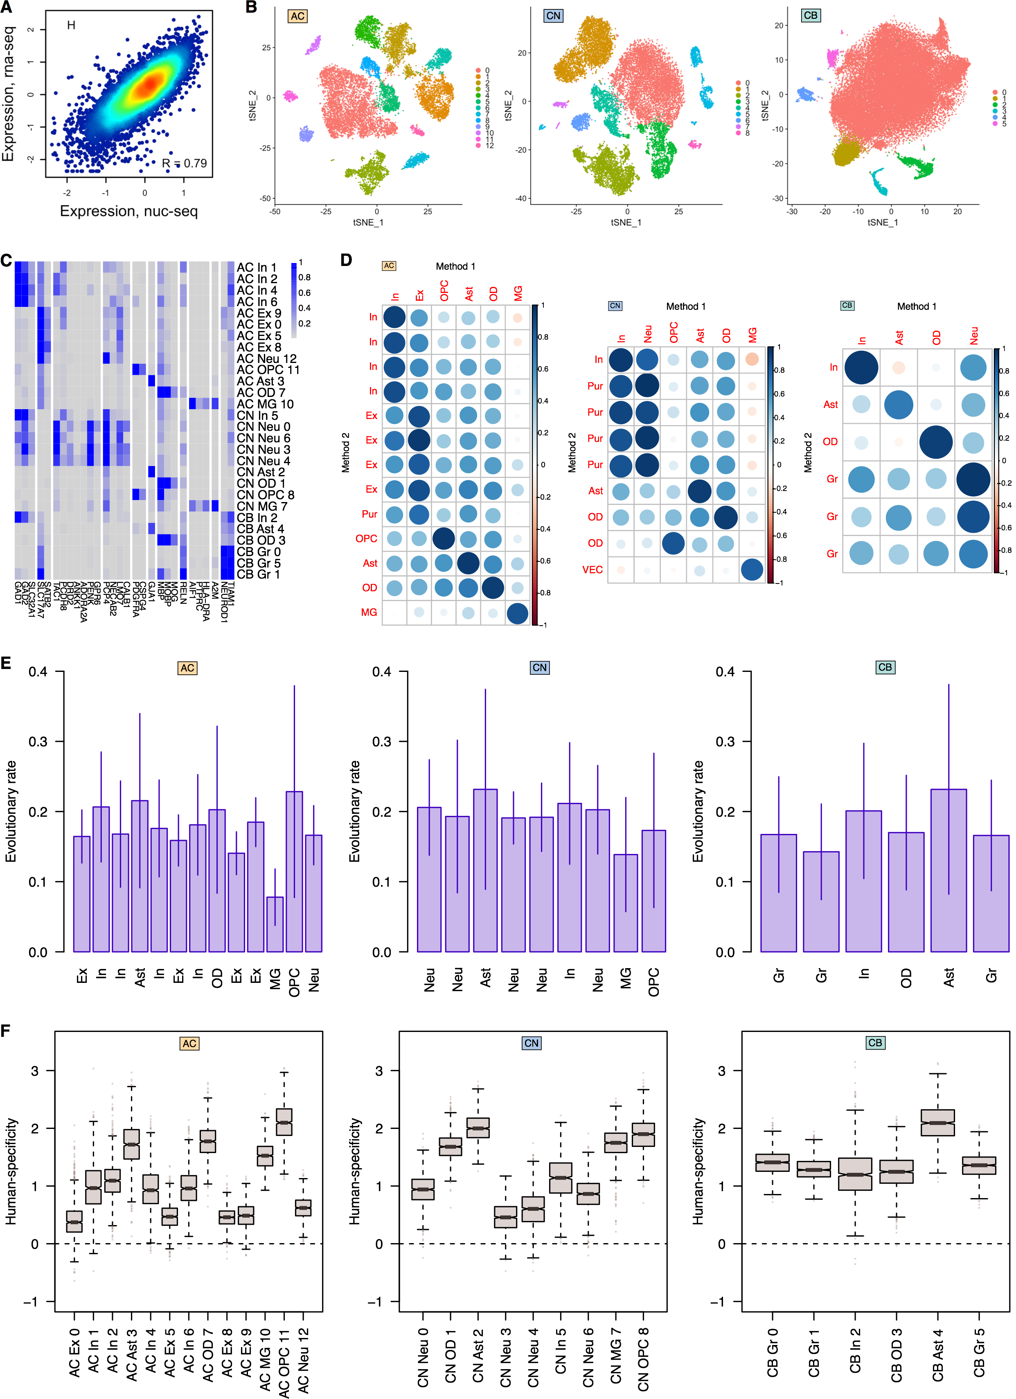

**Supplemental Fig. S54.** snRNA-seq data processed using an alternative procedure [Kanton et al., 2019]. (**A**) Correlation of gene expression levels between bulk RNA-seq and averaged snRNA-seq datasets in human AC. Dots represent genes, and colors show the density of the dots. (**B**) *t*-SNE plots of single nuclei in each of the three brain regions after integration with *Seurat 3.0* [Stuart et al., 2019]. Colors represent cell type clusters. (**C**) Average expression levels of cell type marker genes in *t*-SNE clusters. Abbreviations mark cell types: In – inhibitory neurons; Ex – excitatory neurons; Sn – spindle neurons; Pur – Purkinje cells; OPC – oligodendrocyte progenitor cells; Ast – astrocytes; OD – oligodendrocytes; CR – Cajal-Retzius cells; MG – microglia; VEC – vascular endothelial cells. (**D**) Correlation of gene expression levels between averaged snRNA-seq datasets processed using our method (Method 1) and an alternative procedure [Kanton et al., 2019] (Method 2). Colors and circle sizes represent Pearson’s R. (**E**) The evolutionary rate of cell types within each brain region. Error bars mark the standard deviation of the average estimates. Here and in panel F, we bootstrapped the nuclei 1,000 times by randomly sampling three nuclei per cell type per region per species without replacement. (**F**) Human-specificity ratio calculated within each *t*-SNE cluster in each of the three brain regions. The ratio represents the number of genes with human-specific expression divided by the number of genes with chimpanzee-specific and bonobo-specific expression. Boxes mark the median and the first and the third quartiles of the distribution, and whiskers extend to the 1.5 interquartile ranges. The cell types are abbreviated as in Fig. 3F. ANOVA was not applied to filter genes in this analysis.

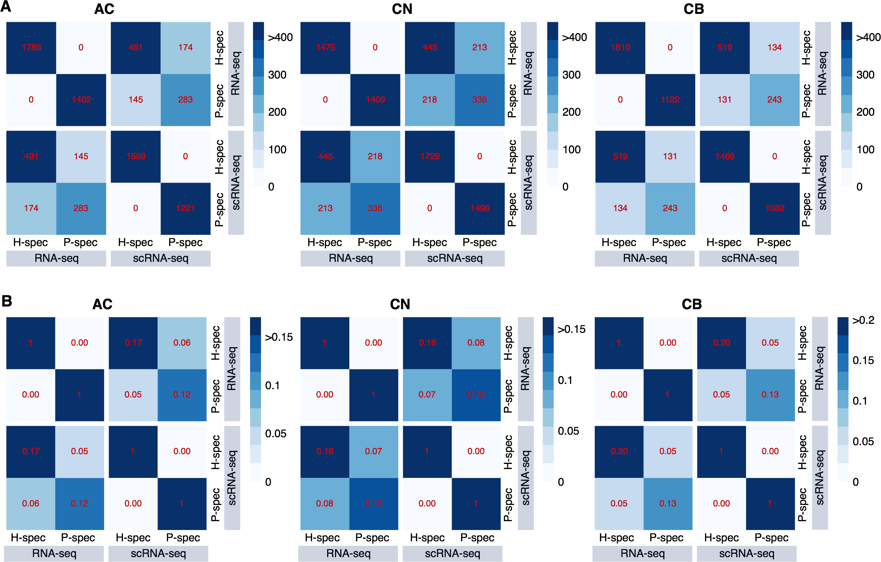

**Supplemental Fig. S55.** Comparison of human-specific (H-spec) and pan-specific (P-spec) genes between RNA-seq and scRNA-seq datasets. (**A**) Shades of blue and numbers on the plot represent numbers of overlapping genes. (**B**) Shades of blue and numbers on the plot represent Jaccard coefficients. Three brain regions are shown, as indicated. Human-specific genes are defined using |H-M| / |C-M| > 2 AND |H-M| / |B-M| > 2 criteria, while pan-specific genes are defined using |C-M| / |H-M| > 2 AND |B-M| / |H-M| > 2 criteria. We additionally required ( |H-M| > 0 or |C-M| > 0 ) AND ( |H-M| > 0 or |B-M| > 0 ) in this analysis.

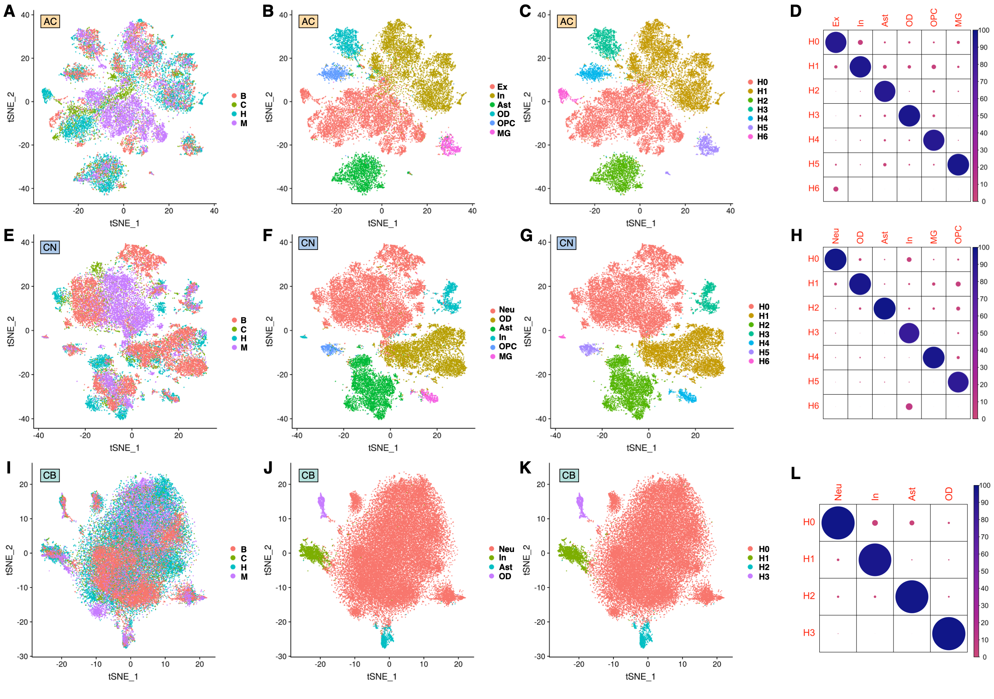

**Supplemental Fig. S56.** snRNA-seq data processed using an alternative batch integration procedure - *harmony* [Korsunsky et al., 2019]. (**A-C**) *t*-SNE plots of single nuclei in AC after integration with *harmony* [Korsunsky et al., 2019]. (**A**) Colors represent species. (**B**) Colors represent clusters previously obtained using integration with *Seurat 3.0* [Stuart et al., 2019]. (**C**) Colors represent clusters obtained using integration with *harmony* [Korsunsky et al., 2019]. (**D**) Agreement between integration using *Seurat 3.0* [Stuart et al., 2019] and *harmony* [Korsunsky et al., 2019] in AC. The size and the color of dots correspond to the proportion of cells matching between *Seurat 3.0* clusters and *harmony* clusters. (**E-G**) *t*-SNE plots of single nuclei in CN after integration with *harmony* [Korsunsky et al., 2019]. (**E**) Colors represent species. (**F**) Colors represent clusters previously obtained using integration with *Seurat 3.0* [Stuart et al., 2019]. (**G**) Colors represent clusters obtained integration with *harmony* [Korsunsky et al., 2019]. (**H**) Agreement between integration using *Seurat 3.0* [Stuart et al., 2019] and *harmony* [Korsunsky et al., 2019] in CN. The size and the color of dots correspond to the proportion of cells matching between *Seurat 3.0* clusters and *harmony* clusters. (**I-K**) *t*-SNE plots of single nuclei in CB after integration with *harmony* [Korsunsky et al., 2019]. (**I**) Colors represent species. (**J**) Colors represent clusters previously obtained using integration with *Seurat 3.0* [Stuart et al., 2019]. (**K**) Colors represent clusters obtained integration with *harmony* [Korsunsky et al., 2019]. (**L**) Agreement between integration using *Seurat 3.0* [Stuart et al., 2019] and *harmony* [Korsunsky et al., 2019] in CB. The size and the color of dots correspond to the proportion of cells matching between *Seurat 3.0* clusters and *harmony* clusters.

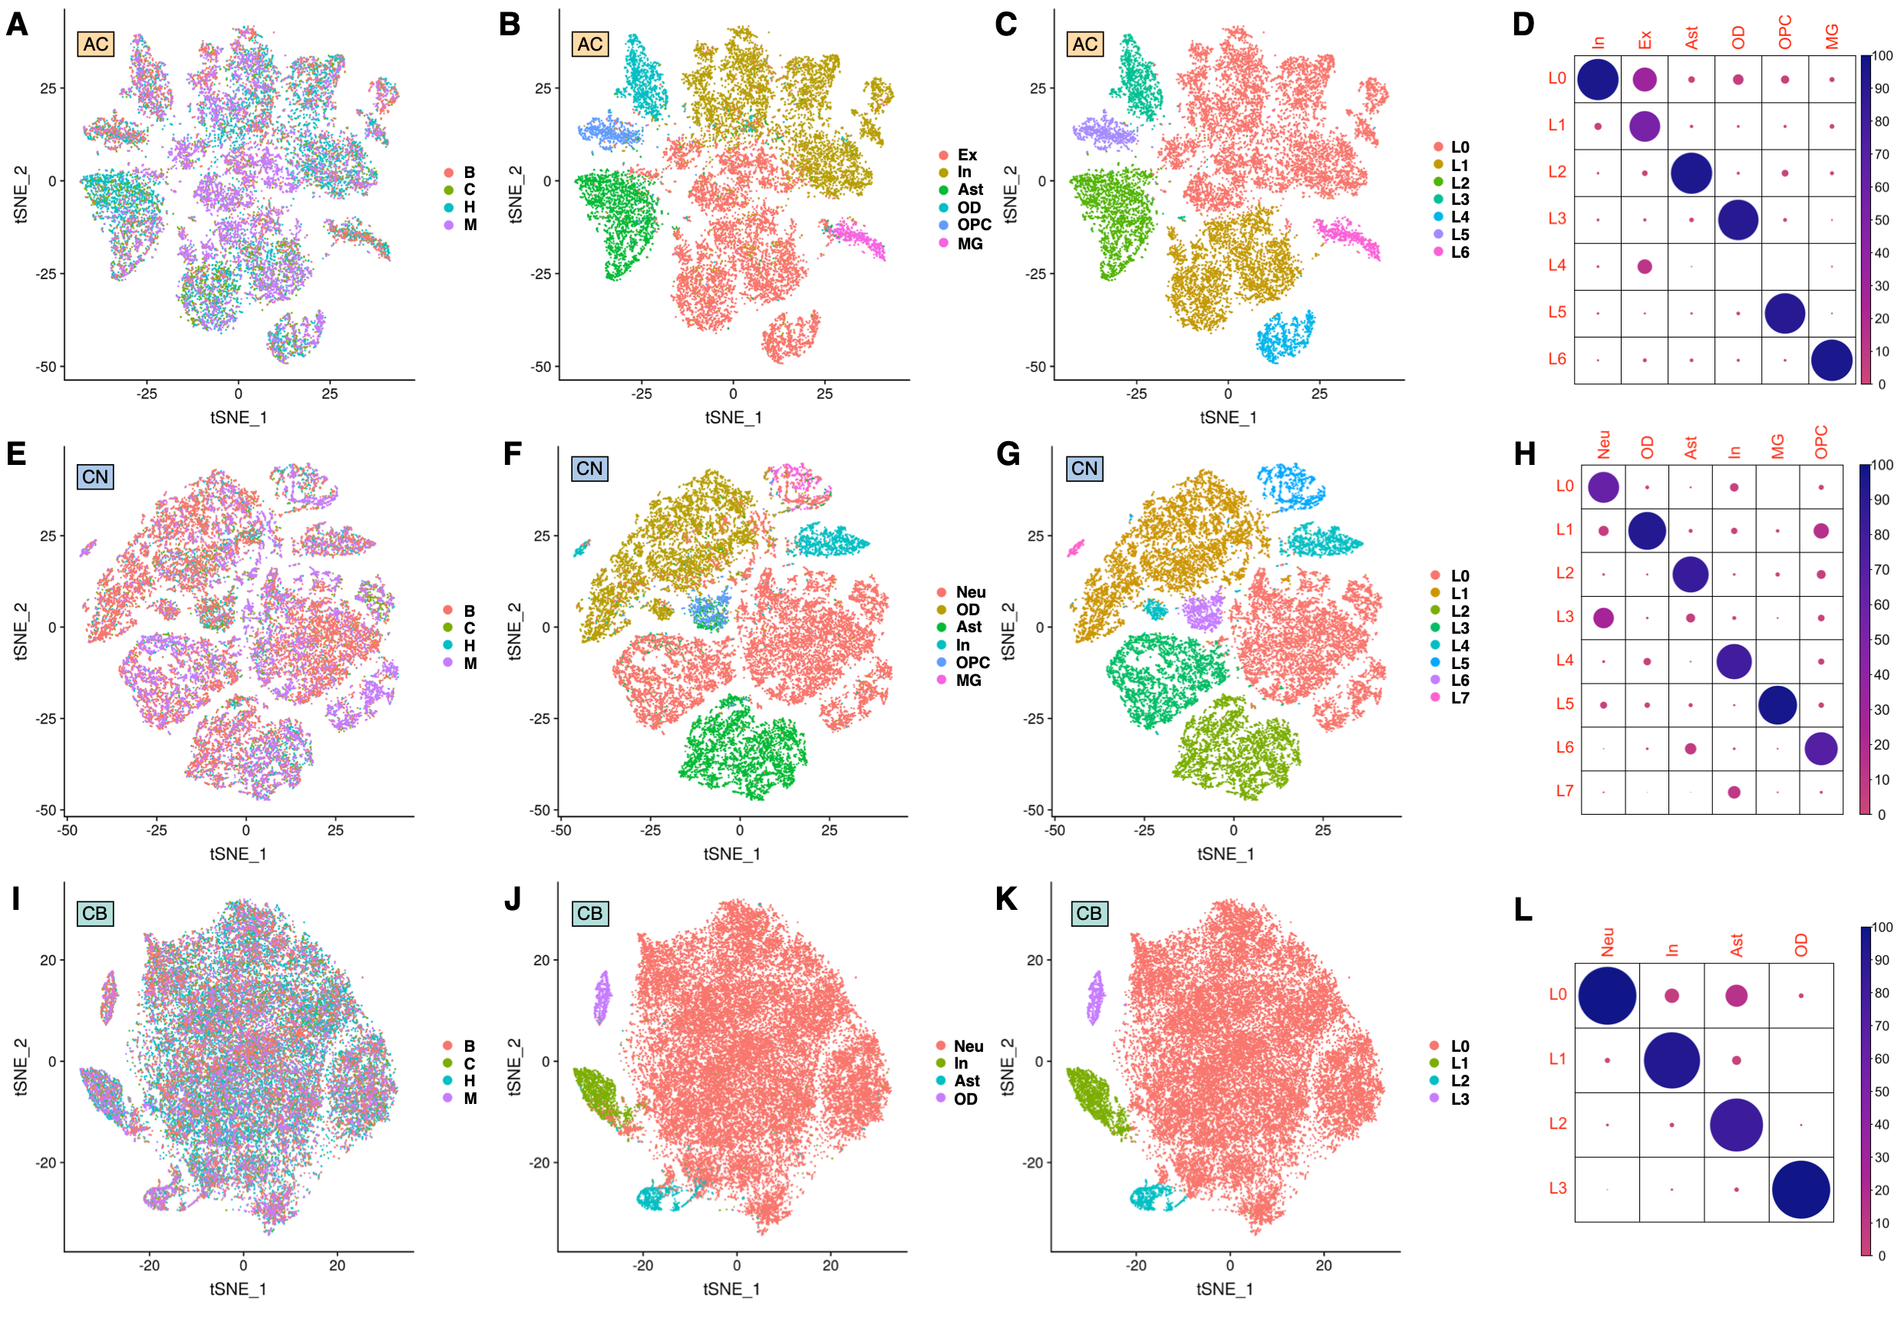

**Supplemental Fig. S57.** snRNA-seq data processed using an alternative batch integration procedure - *liger* [Welch et al., 2019]. (**A-C**) *t*-SNE plots of single nuclei in AC after integration with *liger* [Welch et al., 2019]. (**A**) Colors represent species. (**B**) Colors represent clusters previously obtained using integration with *Seurat 3.0* [Stuart et al., 2019]. (**C**) Colors represent clusters obtained using integration with *liger* [Welch et al., 2019]. (**D**) Agreement between integration using *Seurat 3.0* [Stuart et al., 2019] and *liger* [Welch et al., 2019] in AC. The size and the color of dots correspond to the proportion of cells matching between *Seurat 3.0* clusters and *liger* clusters. (**E-G**) *t*-SNE plots of single nuclei in CN after integration with *liger* [Welch et al., 2019]. (**E**) Colors represent species. (**F**) Colors represent clusters previously obtained using integration with *Seurat 3.0* [Stuart et al., 2019]. (**G**) Colors represent clusters obtained integration with *liger* [Welch et al., 2019]. (**H**) Agreement between integration using *Seurat 3.0* [Stuart et al., 2019] and *liger* [Welch et al., 2019] in CN. The size and the color of dots correspond to the proportion of cells matching between *Seurat 3.0* clusters and *liger* clusters. (**I-K**) *t*-SNE plots of single nuclei in CB after integration with *liger* [Welch et al., 2019]. (**I**) Colors represent species. (**J**) Colors represent clusters previously obtained using integration with *Seurat 3.0* [Stuart et al., 2019]. (**K**) Colors represent clusters obtained integration with *liger* [Welch et al., 2019]. (**L**) Agreement between integration using *Seurat 3.0* [Stuart et al., 2019] and *liger* [Welch et al., 2019] in CB. The size and the color of dots correspond to the proportion of cells matching between *Seurat 3.0* clusters and *liger* clusters.

**SUPPLEMENTAL TABLES**

**Table S1.** Sample information. The table is provided separately as an Excel file (https://cb.skoltech.ru/~khrameeva/brainmap/gr_submission/EB_ST_samples.xlsx).

**Table S2.** Gene expression differences distinguishing humans from chimpanzees, bonobos, and macaques. The table is provided separately as an Excel file (https://cb.skoltech.ru/~khrameeva/brainmap/gr_submission/EB_ST_HSratios.xlsx).

**Table S3.** Genes showing human-specificity in multiple (more than 10 of 33) brain regions. The table is provided separately as an Excel file (https://cb.skoltech.ru/~khrameeva/brainmap/gr_submission/EB_ST_sharedGenes.xlsx).

**Table S4.** Number of nuclei with at least 500 unique detected molecules in each cluster, per species per region. The table is provided separately as an Excel file (https://cb.skoltech.ru/~khrameeva/brainmap/gr_submission/EB_ST_ncells.xlsx).

**Table S5.** Genes preferentially expressed in a specific cell type. The table is provided separately as an Excel file (https://cb.skoltech.ru/~khrameeva/brainmap/gr_submission/EB_ST_markers.xlsx).

**Table S6**. Human accelerated regions **(**HARs) and human-specific genes. The table is provided separately as an Excel file (https://cb.skoltech.ru/~khrameeva/brainmap/gr_submission/EB_ST_enhancers.xlsx).

**Table S7.** Antibodies used for immunohistochemistry analysis. The table is provided separately as an Excel file (https://cb.skoltech.ru/~khrameeva/brainmap/gr_submission/EB_ST_IGH.xlsx).

**Table S8.** Sample coverage and mapping statistics. The table is provided separately as an Excel file (https://cb.skoltech.ru/~khrameeva/brainmap/gr_submission/EB_ST_coverage.xlsx).

**Table S9.** Matching brain regions between Allen Human Brain Atlas and our study. The table is provided separately as an Excel file (https://cb.skoltech.ru/~khrameeva/brainmap/gr_submission/EB_ST_allen.xlsx).

**Table S10.** Number of nuclei with at least 500 unique detected molecules, per species per region. The table is provided separately as an Excel file (https://cb.skoltech.ru/~khrameeva/brainmap/gr_submission/EB_ST_500UMI.xlsx).

**SUPPLEMENTAL REFERENCES**

Berto, S., Mendizabal, I., Usui, N., Toriumi, K., Chatterjee, P., Douglas, C., Tamminga, C.A., Preuss, T.M., Yi, S.V., and Konopka, G. (2019). Accelerated evolution of oligodendrocytes in the human brain. Proc Natl Acad Sci USA *116*, 24334–24342.

Bolger, A.M., Lohse, M., and Usadel, B. (2014). Trimmomatic: a flexible trimmer for Illumina sequence data. Bioinformatics *30*, 2114–2120.

Dobin, A., Davis, C.A., Schlesinger, F., Drenkow, J., Zaleski, C., Jha, S., Batut, P., Chaisson, M., and Gingeras, T.R. (2013). STAR: ultrafast universal RNA-seq aligner. Bioinformatics *29*, 15–21.

Greicius, M.D., Krasnow, B., Reiss, A.L., and Menon, V. (2003). Functional connectivity in the resting brain: A network analysis of the default mode hypothesis. Proceedings of the National Academy of Sciences *100*, 253–258.

Hawrylycz, M.J., Lein, E.S., Guillozet-Bongaarts, A.L., Shen, E.H., Ng, L., Miller, J.A., van de Lagemaat, L.N., Smith, K.A., Ebbert, A., Riley, Z.L., et al. (2012). An anatomically comprehensive atlas of the adult human brain transcriptome. Nature *489*, 391–399.

Hodge, R.D., Bakken, T.E., Miller, J.A., Smith, K.A., Barkan, E.R., Graybuck, L.T., Close, J.L., Long, B., Johansen, N., Penn, O., et al. (2019). Conserved cell types with divergent features in human versus mouse cortex. Nature *573*, 61–68.

Kanton, S., Boyle, M.J., He, Z., Santel, M., Weigert, A., Sanchís-Calleja, F., Guijarro, P., Sidow, L., Fleck, J.S., Han, D., et al. (2019). Organoid single-cell genomic atlas uncovers human-specific features of brain development. Nature *574*, 418–422.

Kim, D., Langmead, B., and Salzberg, S.L. (2015). HISAT: a fast spliced aligner with low memory requirements. Nat. Methods *12*, 357–360.

Korsunsky, I., Millard, N., Fan, J., Slowikowski, K., Zhang, F., Wei, K., Baglaenko, Y., Brenner, M., Loh, P., and Raychaudhuri, S. (2019). Fast, sensitive and accurate integration of single-cell data with Harmony. Nat Methods *16*, 1289–1296.

Mai, J.K., Majtanik, M., and Paxinos, G. (2016). Atlas of the human brain (Amsterdam: Elsevier AP).

Maximo, J.O., and Kana, R.K. (2019). Aberrant “deep connectivity” in autism: A cortico-subcortical functional connectivity magnetic resonance imaging study: Cortico-subcortical connectivity in ASD. Autism Research *12*, 384–400.

Patel, G.H., Yang, D., Jamerson, E.C., Snyder, L.H., Corbetta, M., and Ferrera, V.P. (2015). Functional evolution of new and expanded attention networks in humans. Proc Natl Acad Sci USA *112*, 9454–9459.

Paxinos, G., Huang, X.-F., Petrides, M., and Toga, A.W. (2009). The rhesus monkey brain: in stereotaxic coordinates (Amsterdam: Elsevier, Acad. Press).

Pertea, M., Pertea, G.M., Antonescu, C.M., Chang, T.-C., Mendell, J.T., and Salzberg, S.L. (2015). StringTie enables improved reconstruction of a transcriptome from RNA-seq reads. Nat. Biotechnol. *33*, 290–295.

Pollen, A.A., Bhaduri, A., Andrews, M.G., Nowakowski, T.J., Meyerson, O.S., Mostajo-Radji, M.A., Di Lullo, E., Alvarado, B., Bedolli, M., Dougherty, M.L., et al. (2019). Establishing Cerebral Organoids as Models of Human-Specific Brain Evolution. Cell *176*, 743-756.e17.

R Core Team (2017). R: A Language and Environment for Statistical Computing (Vienna, Austria: R Foundation for Statistical Computing).

Shukla, D.K., Keehn, B., Lincoln, A.J., and Müller, R.-A. (2010). White Matter Compromise of Callosal and Subcortical Fiber Tracts in Children With Autism Spectrum Disorder: A Diffusion Tensor Imaging Study. Journal of the American Academy of Child & Adolescent Psychiatry *49*, 1269-1278.e2.

Sousa, A.M.M., Zhu, Y., Raghanti, M.A., Kitchen, R.R., Onorati, M., Tebbenkamp, A.T.N., Stutz, B., Meyer, K.A., Li, M., Kawasawa, Y.I., et al. (2017). Molecular and cellular reorganization of neural circuits in the human lineage. Science *358*, 1027–1032.

Stuart, T., Butler, A., Hoffman, P., Hafemeister, C., Papalexi, E., Mauck, W.M., Hao, Y., Stoeckius, M., Smibert, P., and Satija, R. (2019). Comprehensive Integration of Single-Cell Data. Cell *177*, 1888-1902.e21.

Washington, S.D., Gordon, E.M., Brar, J., Warburton, S., Sawyer, A.T., Wolfe, A., Mease-Ference, E.R., Girton, L., Hailu, A., Mbwana, J., et al. (2014). Dysmaturation of the default mode network in autism: Dysmaturation of Default Network in Autism. Hum. Brain Mapp. *35*, 1284–1296.

Welch, J.D., Kozareva, V., Ferreira, A., Vanderburg, C., Martin, C., and Macosko, E.Z. (2019). Single-Cell Multi-omic Integration Compares and Contrasts Features of Brain Cell Identity. Cell *177*, 1873-1887.e17.

Yu, G., Wang, L.-G., Han, Y., and He, Q.-Y. (2012). clusterProfiler: an R Package for Comparing Biological Themes Among Gene Clusters. OMICS: A Journal of Integrative Biology *16*, 284–287.

Zerbino, D.R., Achuthan, P., Akanni, W., Amode, M.R., Barrell, D., Bhai, J., Billis, K., Cummins, C., Gall, A., Girón, C.G., et al. (2018). Ensembl 2018. Nucleic Acids Res. *46*, D754–D761.

Zheng, G.X.Y., Terry, J.M., Belgrader, P., Ryvkin, P., Bent, Z.W., Wilson, R., Ziraldo, S.B., Wheeler, T.D., McDermott, G.P., Zhu, J., et al. (2017). Massively parallel digital transcriptional profiling of single cells. Nature Communications *8*, 14049.